

**ONLINE LEARNING**

**Software Requirement Specification**

– Hanoi, May 2022 –

**Table of Contents**

I. Overview **4**

1. Introduction 4

2. System Functions 5

a. Screen Flow 5

b. Screen Details 8

c. User authorization 12

d. Non-Screen Functions 14

3. Common Requirements 15

II. Functional Requirements **16**

1. Common features 16

a. User login 16

b. User Register: 17

c. Reset Password: 18

d. User Authorization: 19

e. User profile 19

f. Change Password: 20

2. Public Feature: 21

a. Home Page 21

b. Blogs List: 22

c. Blog Details: 22

d. Courses List: 23

e. Courses Details: 23

f. Course Register: 24

3. Administrator Feature: 24

b. Users List: 24

b. Users Details: 25

c. Settings List: 25

d. Setting Details: 25

4. Marketing Feature: 26

a. Dashboard: 26

b. Post List: 27

c. Post Details: 27

d. Slider List: 28

e. Slider Details: 28

5. Customer/Learning Feature: 28

a. My Registrations: 28

b. My Courses: 29

c. Lesson View: 29

d. Quiz Lesson: 30

e. Quiz Handle: 31

f. Quiz Review: 32

6. Course Content Feature: 33

a. Subject List: 33

b. New Subject: 34

c. Subject Details: 34

e. Price Package: 35

f. Subject Lessons: 36

g. Lesson Details: 37

h. Subject Dimension 37

7. Test Content Feature: 38

a. Question List: 38

b. Question Details: 39

c. Question Import: 40

d. Quizzes List: 40

e. Quiz Details: 41

8. Sale Feature: 42

a. Registrations List: 42

b. Registration Details: 42

# I. Overview

## 1. Introduction

This project is aimed at developing an online learning system which supports for

the organisation/expert to build up and sell the online course, supports the user to

search-register-and-access online course for learning. This system support for the

below types of users.

* Guess: unregistered users.
* Customer: they are registered users who are actual customers or potential customers.
* Marketing: the marketing members of the organisation.
* Sale: the sale members of the organisation.
* Expert: access and prepare the course/test contents as assigned by admin.
* Admin: the organisation leader/manager, acts as the system administration.

## 2. System Functions

#### a. Screen Flow

**- Guest:**

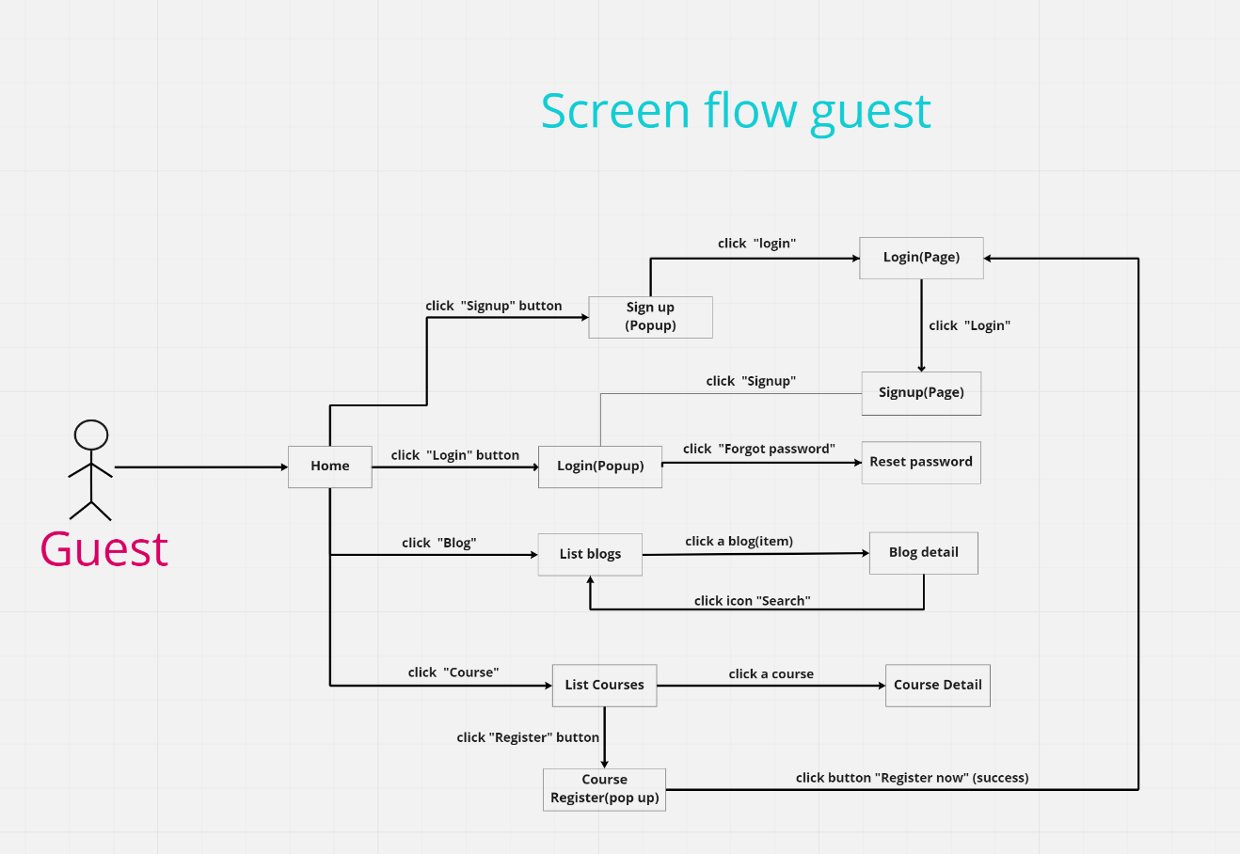

**- User:**

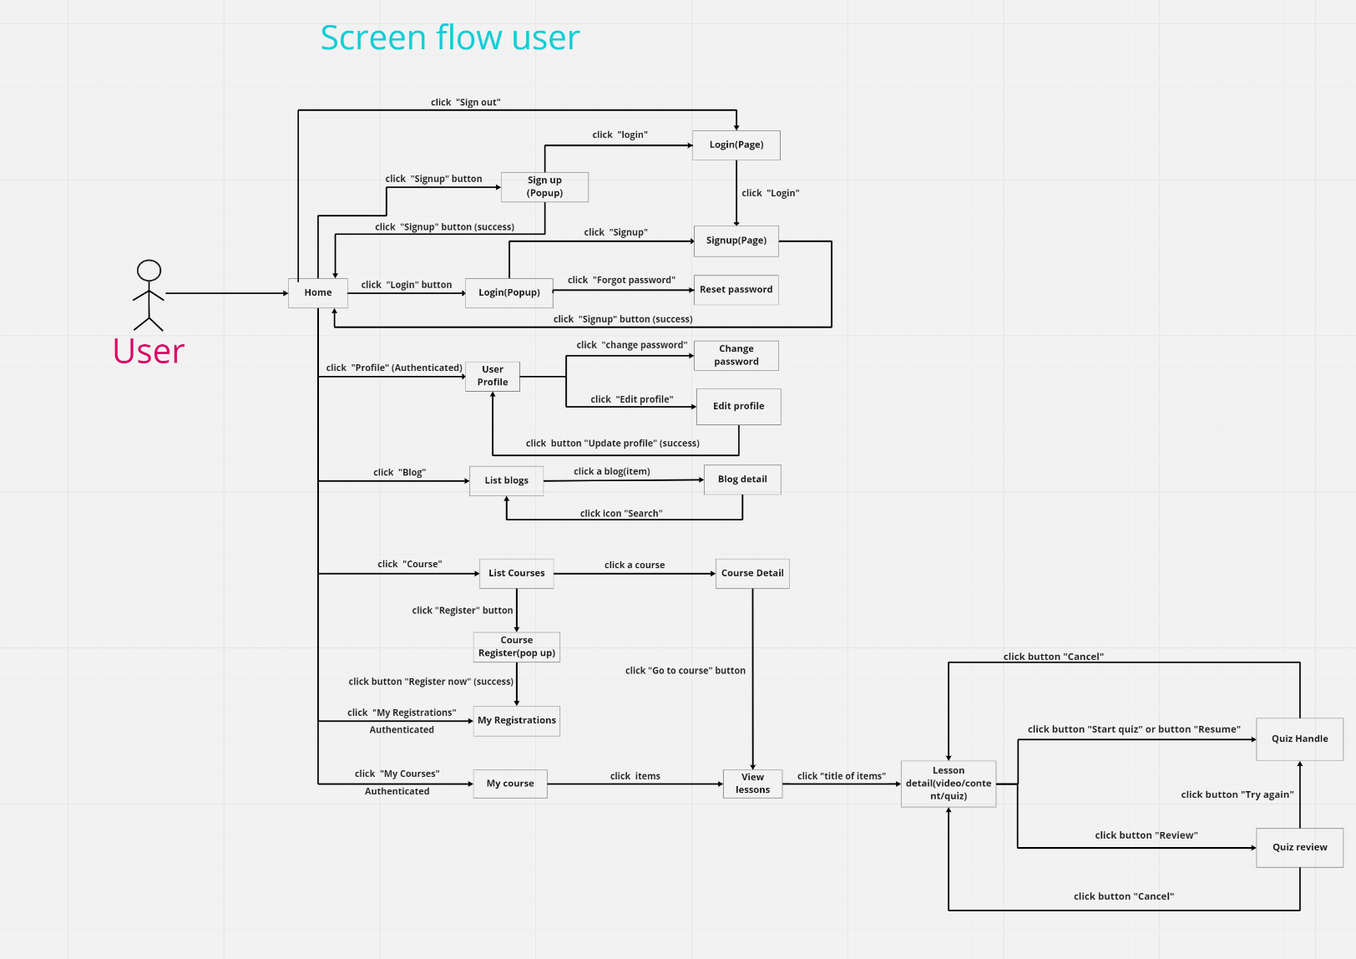

**- Admin**

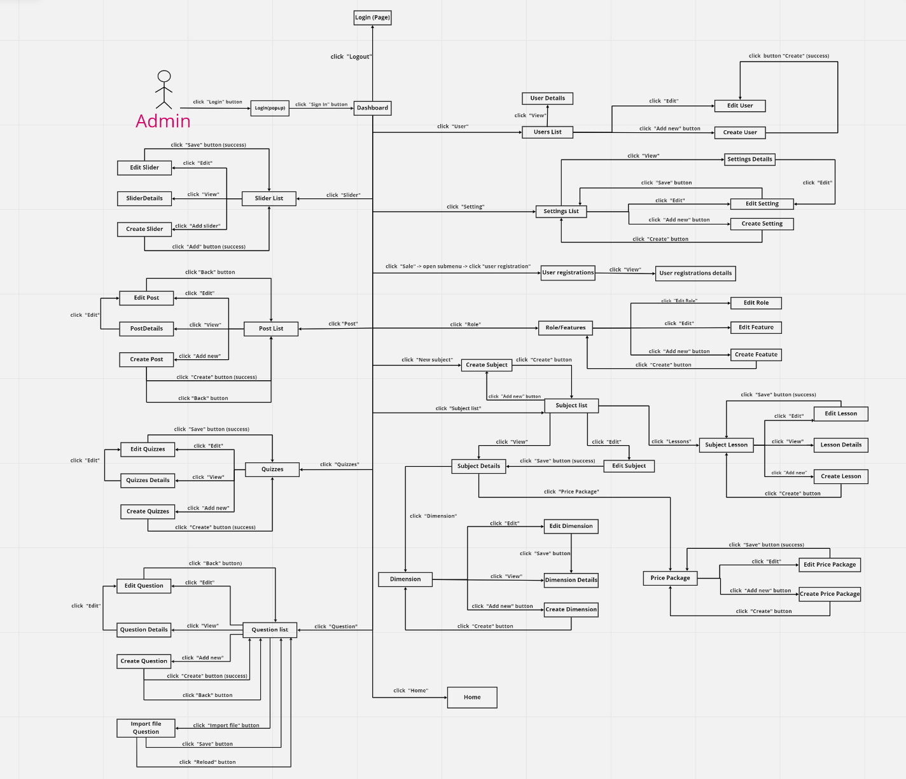

- **Marketing**

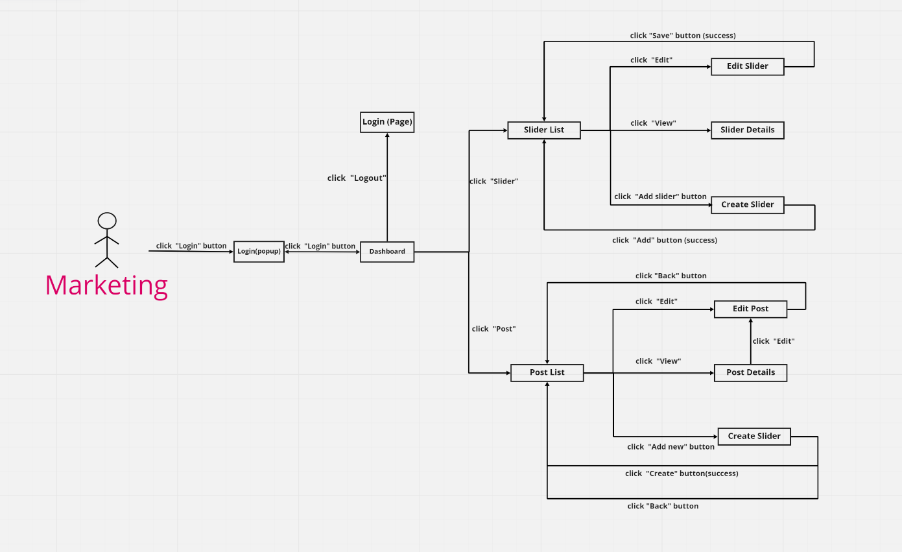

**- Sale**

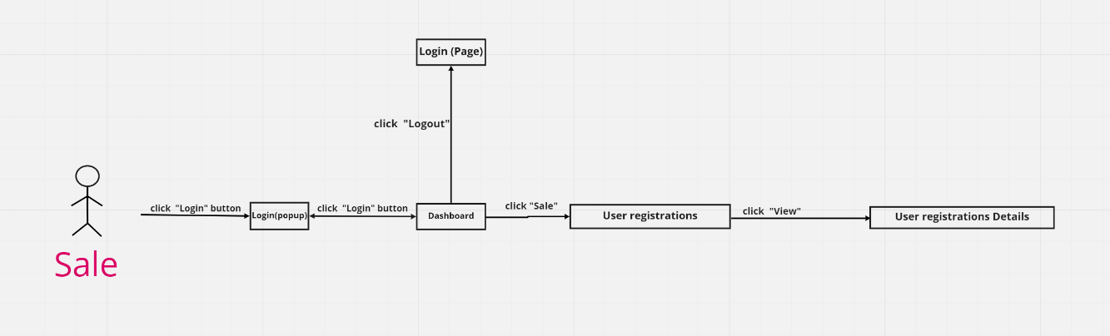

* **Expert**

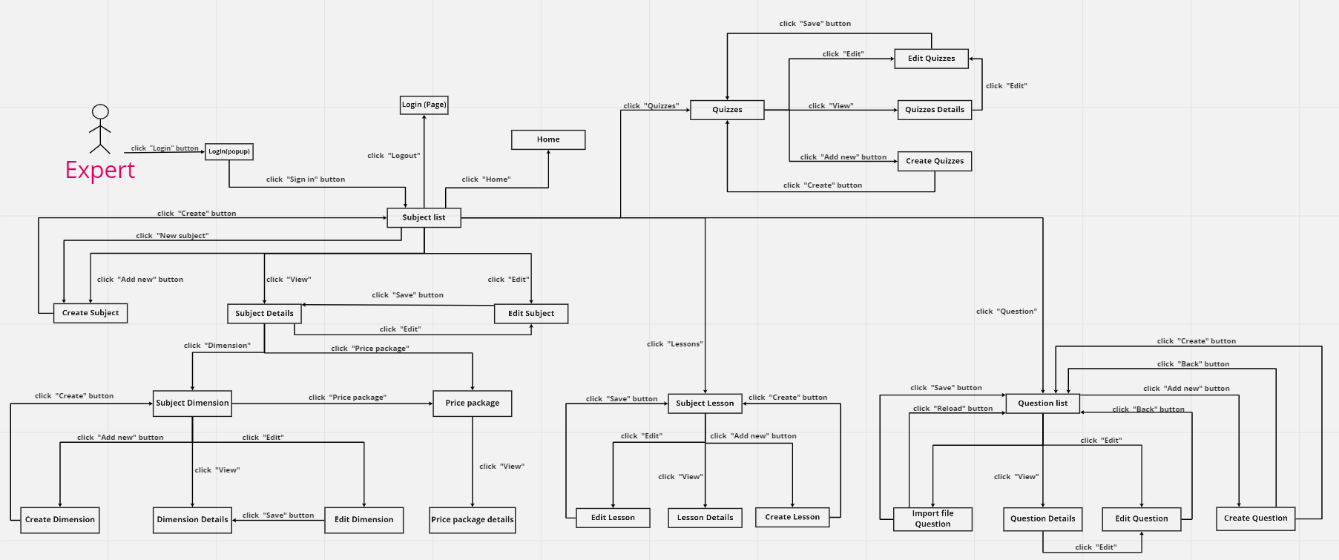

* **Manager**

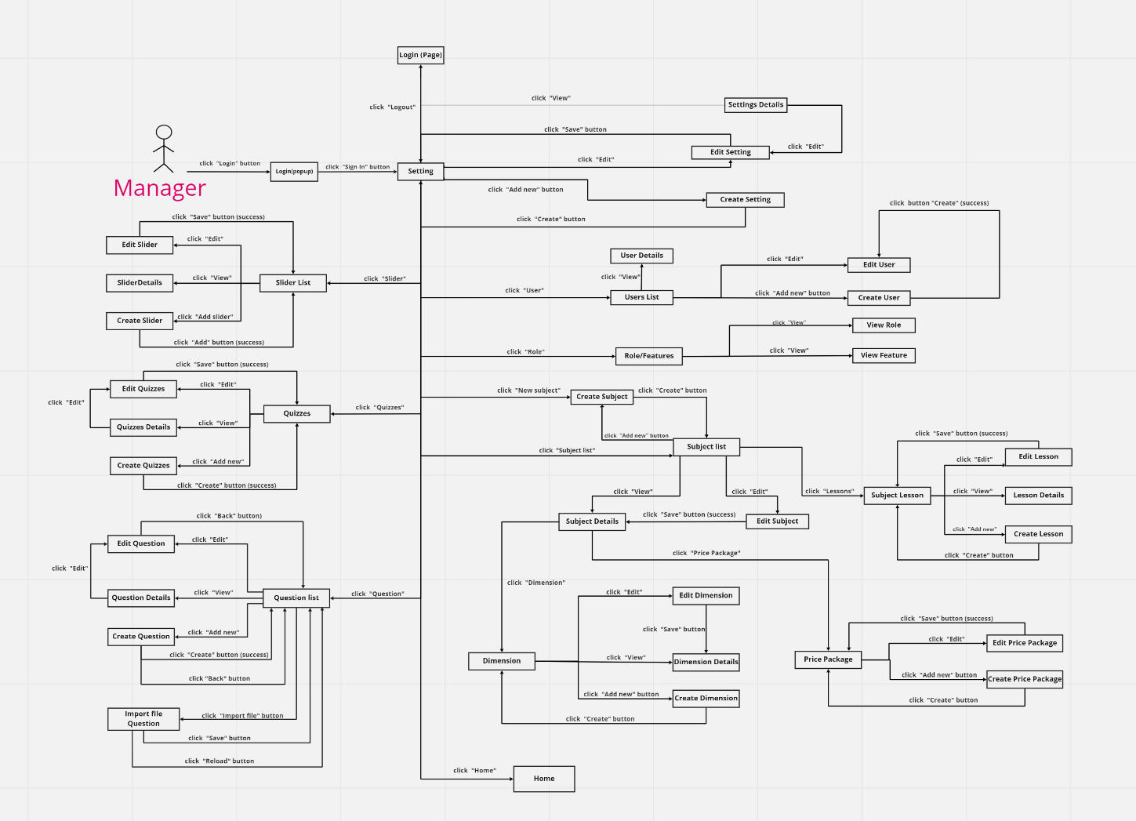

#### b. Screen Details

| **#** | **Screen** | **Feature** | **Description** |
| --- | --- | --- | --- |
| 1 | Home | Common | Show sliders, hot posts, featured subjects + the sider with the latest posts, static contacts/links  - Shown slider information includes its image and title; the user is redirected to the slider's backlink on his/her clicking  - Shown post information includes its thumbnail, title, postdate; the user is redirected to the post's details on his/her clicking  - Shown subject information includes its thumbnail, title, tag line; the user is redirected to the subject’s details on his/her clicking |
| 2 | User Login | Common | This is a pop-up screen which allows the user to enter email & password to login; on this page, there are also options for user to register new information or reset the password for the case s/he forget it |
| 3 | User Register | Common | This is a pop-up screen which allows the user to register himself/herself to the system by inputting following information: full name, gender, email, mobile; User then need to verify by clicking the link sent via email to him/her before being able to access the system |
| 4 | Reset Password | Common | The user input his/her email to receive the reset password link. This link is sent to the user's email for his/her password resetting.  - On clicking the link, the user is redirected to the password resetting page in which s/he input new password (twice) for the system access  - Note that the link is only available for a specific time duration as configured in the system config file. |
| 5 | User Authorization | Common | Implementation of authorization mechanism in the system, including the specify the role of logged-in user, his/her authorised page links (building the displayed menu items (in the front end) and preventing unauthorised access via enter the links directly) |
| 6 | User Profile | Common | This is a pop-up screen which allows the user to edit his/her profile information, including the registered ones & the avatar image. Please note that s/he is not allowed to change the email |
| 7 | Change Password | Common | This is a pop-up screen which allows the user to change his/her password by inputting his current password as well as new password (twice) |
| 8 | Blogs List | Public | Show the posts pagination (sorted by updated date) + the sider with the post search box, posts categories, latest posts, static contacts/links; Shown post information includes its thumbnail, title, category, brief-info; the user is redirected to the post's details on his/her clicking |
| 9 | Blog Details | Public | Show post details (including title, author, updated date, category, and post details) + the sider with the post search box, posts categories, latest posts, static contacts/links |
| 10 | Courses List | Public | Show the subjects paginated (sorted by updated date, paginated) + the sider with the subject search box, subject categories, featured subjects, and static contacts/links.  - Shown subject information includes its thumbnail, title, tag line, lowest price package option (list price, sale price).  - The user is redirected to the subject's details on his/her clicking on the subject  - The user can choose to register to the subject by clicking the Register button |
| 11 | Course Details | Public | Show subject details (including title, tag line, brief info, lowest price package option (original price, sale price), product description, and a Register button) + the sider with the subject search box, subject categories, featured subjects, static contacts/links |
| 12 | Course Register | Public | This is a pop-up screen which allows the user to register for access to a subject. On this screen, the user needs to choose appropriate subject price package & input his/her information (full name, email, mobile, gender); A logged in user doesn't have to input those contact information |
| 13 | My Registrations | Customer | Show the list of user's registration + the sider with the subject search box, subject categories, static contacts/links  - Each registration includes below information: id, subject, registration time, package, total cost, status, valid from, valid to;  - If the registration is still in the submitted status, the users can choose to cancel it or coming back to the Course Register pop-up to edit it) |
| 14 | My Courses | Customer | For the customer to view his/her access-allowed courses |
| 15 | Lesson View | Customer | Allow customer to access the course lessons for his/her studying |
| 16 | Quiz Lesson | Customer | This allows the user to take the topic quiz or view the quiz results |
| 17 | Quiz Handle | Learning | This screen allows the user to browse and answer the quiz questions |
| 18 | Quiz Review | Learning | This screen allows the user to review the details of the quiz that s/he has just taken |
| 19 | Dashboard | Marketing | Show statistics of new subjects (new, all), new registrations (success, cancelled, submitted), revenues (total, by subject categories), customers (newly registered, newly bought), and the trend of order counts (success, all) by day for the last 7 days (the start date & end date can be adjustable) |
| 20 | Post Details | Marketing | Show detailed post information (thumbnail, category, title, brief information, description, flag to turn the featuring on/off, status), from that allow the user to input, view or edit them |
| 21 | Post list | Marketing | Show the paginated list of posts (include posts' id, thumbnail, title, category, author, featured, and status information):  - The user can filter the post by category, author, status; also the user can search the post by title  - The list can be sortable by title, category, author, featured, or status  - The page also have the button/link that allows the user to add new or choose to view/update/show/hide an existing post |
| 22 | Sliders List | Marketing | Show the paginated list of sliders (including sliders' id, title, image, backlink, status)  - The user can filter the sliders by the status + search by title or backlink  - For each slider, the user can choose to hide, show, edit it |
| 23 | Slider Details | Marketing | Show detailed slider information (image, title, backlink, status, notes) |
| 24 | Subjects List | Course Content | Show the list of course paginated. The shown information for each subject includes the id, name, category, number of lessons, owner, and status  The user can:  - Filter the list by course category & status  - Search the course by the name  - Choose to add new course (redirect the user to the New Subject page for that)  - Edit course information (linked to the Subject Details for that) |
| 25 | New Subject | Course Content | The screen is shown with below information for the user to input new course information: name, thumbnail image, category, featured flag, owner, status, and description |
| 26 | Subject Details | Course Content | This page allows the admin and the assigned expert to access and prepare the subject information, including the course general information, the dimension, and price package. Only the admin can change the status to Published or Unpublished + add/edit the price packages |
| 27 | Subject Dimension | Course Content | This page allows the admin/expert to input or edit subject dimension information, including the following detailed information: type, name, description |
| 28 | Price Package | Course Content | This page allows the admin to input or edit subject dimension information, including the following detailed information: name, access duration (in months), status (read-only), list price, sale price, description. The expert can only view the information. |
| 29 | Subject Lessons | Course Content | This page shows the list of lessons for a selected package. On this page, the admin/expert is allowed to activate/deactivate, or call the Lesson Details for adding new or editing existing lesson |
| 30 | Lesson Details | Course Content | This page allows the admin/expert to input/edit the lesson information |
| 31 | Questions List | Test Content | The existing questions list for a specific subject/course are shown here (paginated). On this screen, the admin/expert is allowed to filter the questions by the subject, lesson, dimension(s), level, status + search the questions by content  Below information is shown for each question in the list: id, content, subject /dimension /lesson, level, status + options to show, hide, edit it; The page also allows the user to import the question (redirect him/her to the Questions Import pop-up screen. |
| 32 | Question Details | Test Content | This page allows the admin/expert to input or edit questions information, including following information: subject, dimension(s), lesson, status, content, media (image, audio, video – with preview option), answer options (with the key marked + ability to add, edit, delete), and explanation |
| 33 | Question Import | Test Content | This is a pop-up screen which allows the user to choose the import file and then import the questions in the file into the questions bank. The screen also provides the option for the user to download the sample import template. |
| 34 | Quizzes List | Test Content | The existing quizzes are shown in this page paginated:  - The user can filter the list by subject, quiz types + search quizzes by the name  - Each quiz includes following information: id, name, subject, level, # question, duration, pass rate, and the quiz type.  From this page, the user has the option to call to the Quiz Details page for adding new or editing existing quizzes + delete the quiz. Please note that the quiz can be edited only when there is not any test taken yet. |
| 34 | Quiz Details | Test Content | This page allows the user to input or edit quiz information |
| 36 | Registrations List | Sale | Show the list of users' registrations  - Each registration includes below information: id, email, registration time, subject, package, total cost, status, valid from, valid to, last updated by;  - The user can filter the list by subject (searchable), registration time (from, to), status + can search by the email  - The list can be sorted by id, email, registration time, subject, package, total cost, status, valid from, valid to  - From the list, the user can choose to add new or edit an existing registration via the Registration Details screen as below |
| 37 | Registration Details | Sale | Show detailed registration information (subject, package with list price/sale price, full name, gender, email, mobile), registration time, sale, status, valid from, valid to, notes) from that for the user to add new or change the status of a registration with relevant notes (if a registration is created by the user, then s/he can edit other registration information). On changing a registration status to Paid, if the user with relevant registered email does not exist, the system would create one and send back to the user the login information (link, email, pass) along with the other notification notes |
| 38 | Users List | Admin | Show the paginated list of registered users (include users' id, full name, gender, email, mobile, role, status):  - The admin can filter the users by gender, role, status  - Allow the admin to search users by full name, email, mobile  - The list is sortable by id, full name, gender, email, mobile, role, status  - From each user, the admin can choose to view or edit it  - The page also has the button/link that allows the admin to add new user |
| 39 | User Details | Admin | Show detailed user information (avatar, full name, gender, email, mobile, role, address, status), from that allow the user to add new, view or edit user information  - After adding, new generated login password would be email to the new user  - The admin can only edit/update the role and status of the user |
| 40 | Settings List | Admin | Show the paginated list of settings (include settings' id, type, value, order, status):  - The admin can filter the setting by type, status  - Allow the admin to search settings by value  - The list is sortable by id, type, value, order, status  - From each setting, the admin can choose to view, activate/deactivate, or edit it  - The page also has the button/link that allows the admin to add new setting |
| 41 | Setting Details | Admin | Show detailed user information (type, value, order, description, status), from that allow the user to add new, view or edit setting information |

#### c. User authorization

| STT | **Screen** | **Guest** | **Customer** | **Marketing** | **Sale** | **Expert** | **Admin** |
| --- | --- | --- | --- | --- | --- | --- | --- |
| 1 | Home | x | x |  |  |  |  |
| 2 | User Login | x | x |  |  |  |  |
| 3 | User Register | x |  |  |  |  |  |
| 4 | Reset Password |  | x |  |  |  |  |
| 5 | User Authorization |  | x |  |  |  | x |
| 6 | User Profile |  | x |  |  |  |  |
| 7 | Change Password |  | x |  |  |  |  |
| 8 | Blogs List |  |  | x |  | x | x |
| 9 | Blog Details |  |  | x |  | x | x |
| 10 | Courses List |  | x | x |  | x | x |
| 11 | Course Details |  | x | x | x | x | x |
| 12 | Course Register |  |  | x | x | x | x |
| 13 | My Registrations |  | x |  |  |  |  |
| 14 | My Courses |  | x |  |  |  |  |
| 15 | Lesson View |  | x |  |  |  |  |
| 16 | Quiz Lesson |  | x |  |  |  |  |
| 17 | Quiz Handle |  | x |  |  |  |  |
| 18 | Quiz Review |  | x |  |  |  |  |
| 19 | Dashboard |  |  | x | x | x | x |
| 20 | Post Details |  |  | x |  |  |  |
| 21 | Post list |  |  | x |  |  |  |
| 22 | Sliders List |  | x | x |  |  |  |
| 23 | Slider Details |  | x | x |  |  |  |
| 24 | Subjects List |  |  | x | x | x | x |
| 25 | New Subject |  |  | x | x | x | x |
| 26 | Subject Details |  |  | x | x | x | x |
| 27 | Subject Dimension |  |  | x | x | x | x |
| 28 | Price Package |  |  |  | x |  | x |
| 29 | Subject Lessons |  | x |  |  | x |  |
| 30 | Lesson Details |  | x |  |  | x |  |
| 31 | Questions List |  |  |  |  | x |  |
| 32 | Question Details |  |  |  |  | x |  |
| 33 | Question Import |  |  |  |  | x |  |
| 34 | Quizzes List |  |  |  |  | x |  |
| 35 | Quiz Details |  |  |  |  | x |  |
| 36 | Registrations List |  |  |  |  | x |  |
| 37 | Registration Details |  |  |  |  | x |  |
| 38 | Users List |  |  | x | x |  | x |
| 39 | User Details |  |  | x | x |  | x |
| 40 | Settings List |  |  | x | x |  | x |
| 41 | Setting Details |  |  | x | x |  | x |

#### d. Non-Screen Functions

| **#** | **Feature** | **System Function** | **Description** |
| --- | --- | --- | --- |
| 1 | Security | System security requirements | Security is the security requirements in the process of using the system. From accessing, performing operations, printing documents, to logging out of the system |
| 2 | Authorization | Clear role assignment requirements | Implementation of authorization mechanism in the system, including the specify the role of logged-in user, his/her authorised page links (building the displayed menu items (in the front end) and preventing unauthorised access via enter the links directly) |
| 3 | Accessibility | Accessibility is the key to making the project reach as many people as possible | The functions in the project should be simple, easy to use and access, and be clear. |
| 4 | Easy to learn | Is the system "easy to learn" of the system. Often people will look at the consistency of screen forms to evaluate. | For example, in the Customer screen form, the Navigation bar is at position A, the Command bar is at position B, the NEW button is at position C. In the Order screen form, the Navigation bar is at position C, the Command bar is at position position A, the New button at position B, is considered to be the end of the user movie.  They can't remember, and they don't even need to.  Those problems will cause user discomfort and reduce users |

## 3. Common Requirements

# II. Functional Requirements

## 1. Common features

### a. User login

* Function trigger: This use case starts when a user clicks the “Sign in” button on the Menu
* Function description: User sign in into the system.
* Screen layout:

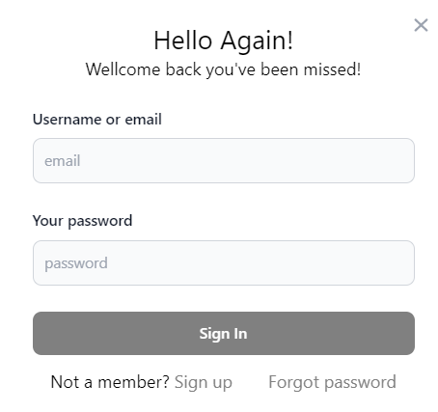

* Function details:
* The system prompts the user to enter a email and password
* The user enters email and password, the system validates the input after the user clicks “Login”. If the email is associated with an account in the system and the password is correct with the entered email, the system lets the user login
* If a user does not have an account in the system, the user can click “Sign up” either at the Menu or login page. One the account is created; the user can consider logging in to the system with the created account. See “Login” use case.
* User forgets password: If the user forgets password, the user can click on “Forgot password” below the password field to reset password using the email which user used to create the
* account.

### b. User Register:

* Function trigger: This function is triggered when the guest goes to login and choose to register
* Function description: create an account.
* Screen layout:

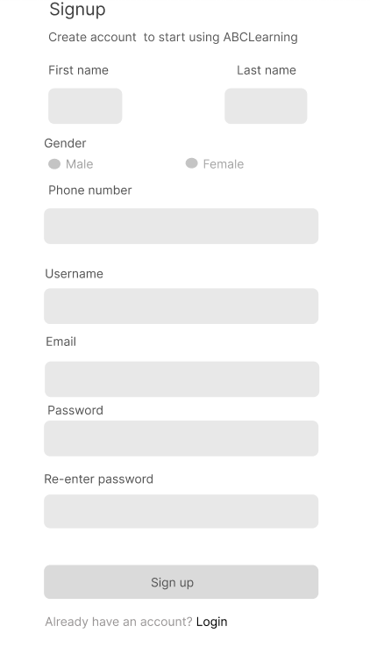

* Function details:

This is a pop-up screen which allows the user to register himself/herself to the system by input following information: full name, gender, email, mobile; User then needs to verify by clicking the link sent via email to him/her before being able to access the system.

### c. Reset Password:

* Function trigger: User click “Forgot password” in Login page
* Function description: User want reset password
* Screen layout
* Reset password

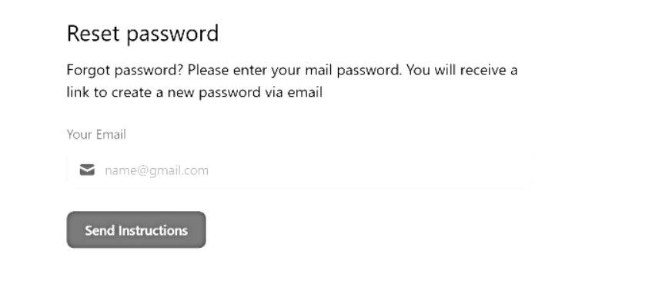

* Check your mail

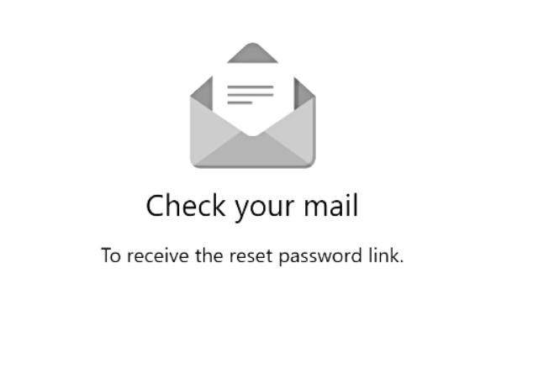

* Content email

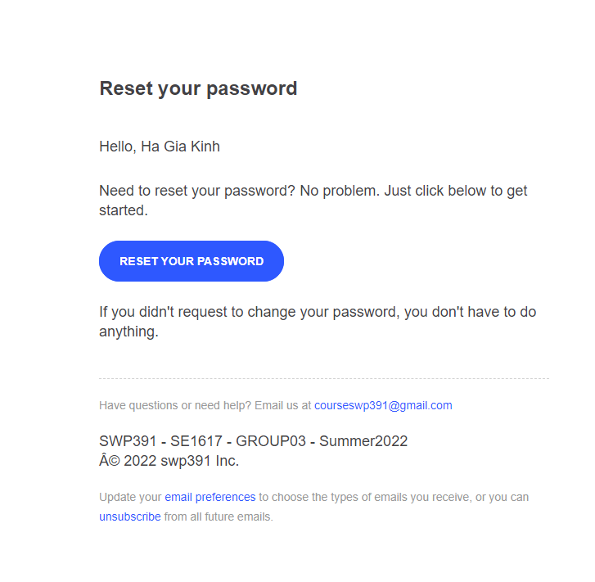

* Created new password

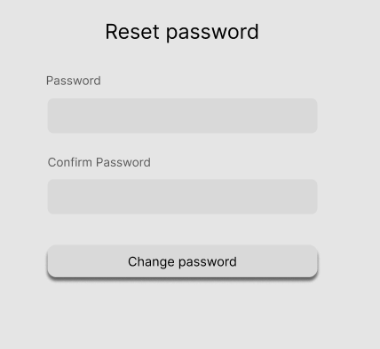

* Function detail:
* Input email in email text area
* Click “Send instructions” button to send code in email input
* Click “Open email”
* Input new password in password text area
* Input re-password in re-password text area
* Click “Reset Password” to reset password

### d. User Authorization:

* Function trigger: Display a list of user functions corresponding to their role
* Function description: Role-based function display system
* Screen layout:
* Show information:

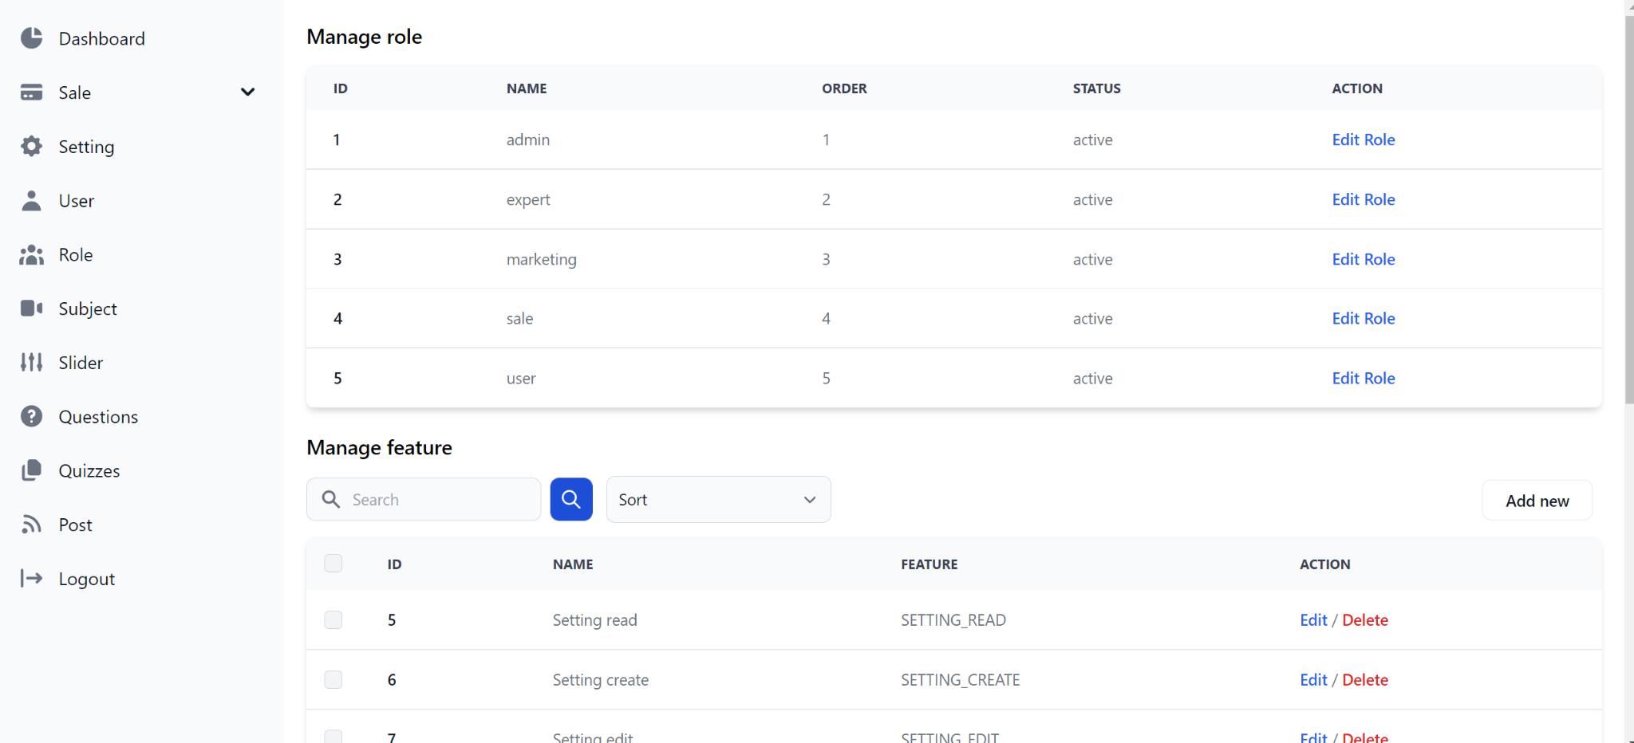

* Update feature role:

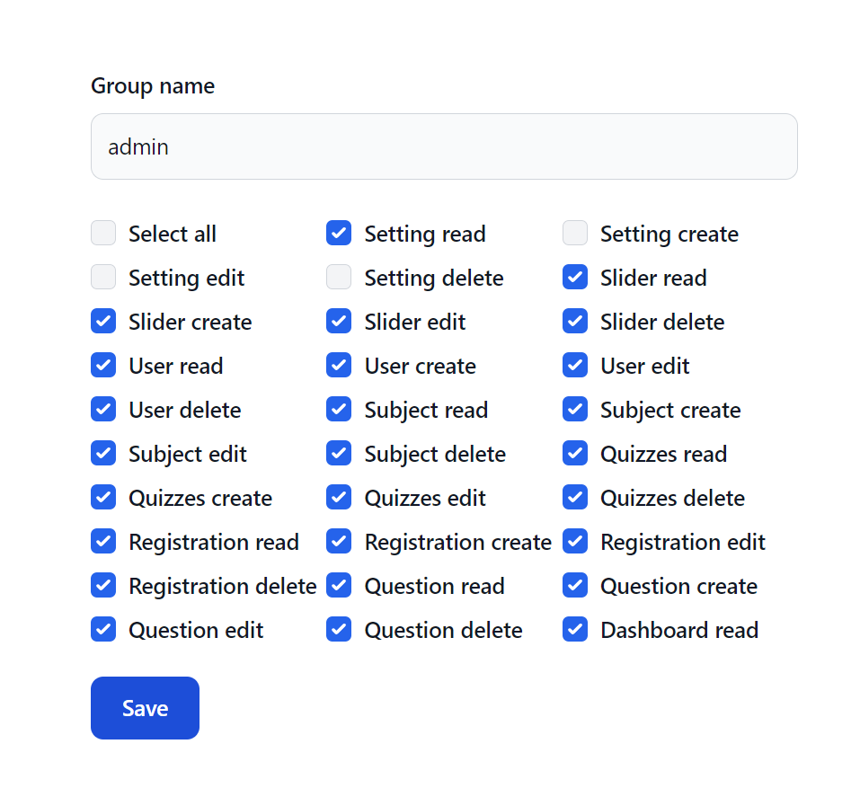

* Manage feature:

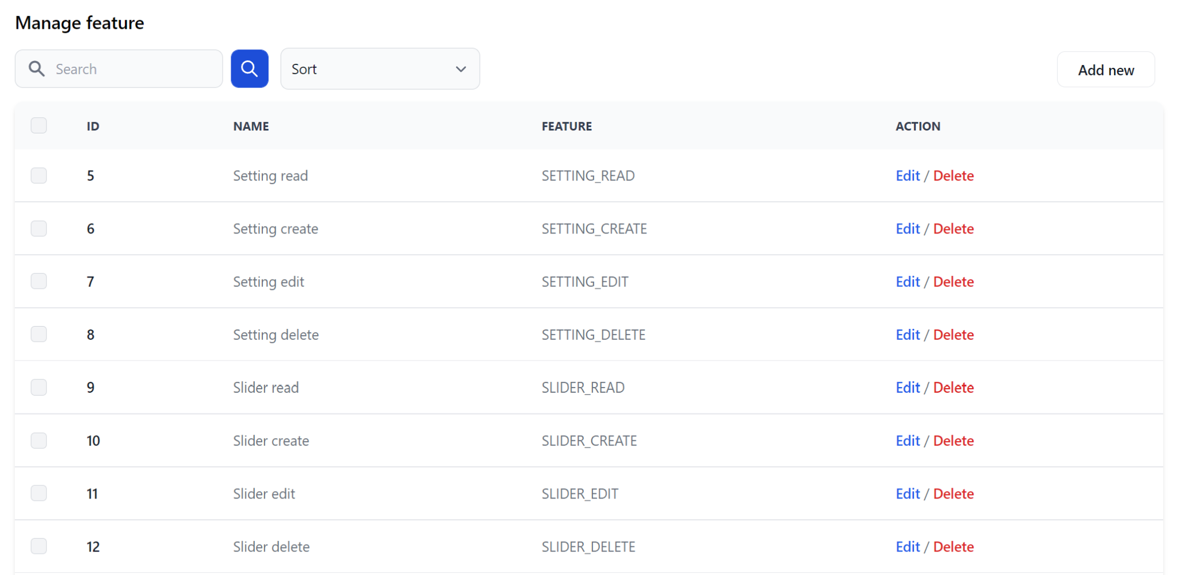

* Slider bar:

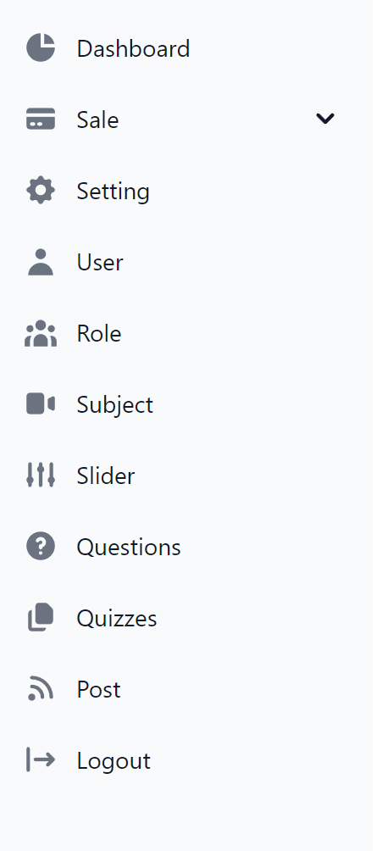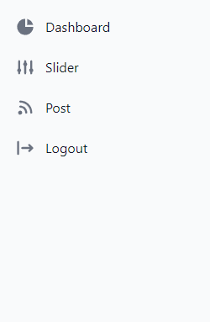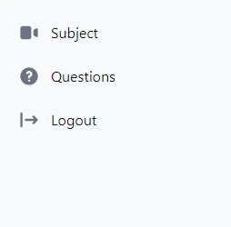

* Function detail:
* Implementation of authorization mechanism in the system, including the specify the role of logged-in user, his/her authorised page links (building the displayed menu items (in the front end) and preventing unauthorised access via enter the links directly)

### e. User profile

* Function trigger: After login User click avatar, choose “Profile”
* Function description: User want change, see profile
* Screen layout:
* Edit profile:

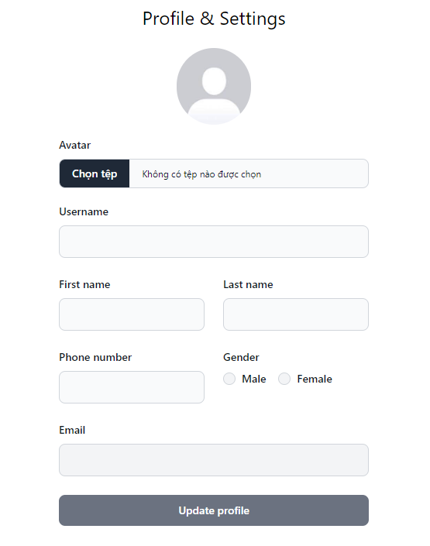

* Function details:
* Show all information of user

### f. Change Password:

* Function trigger: When the user clicks “My profile” from avatar in Homepage and click “Change password”.
* Function description: Change password
* Screen layout:

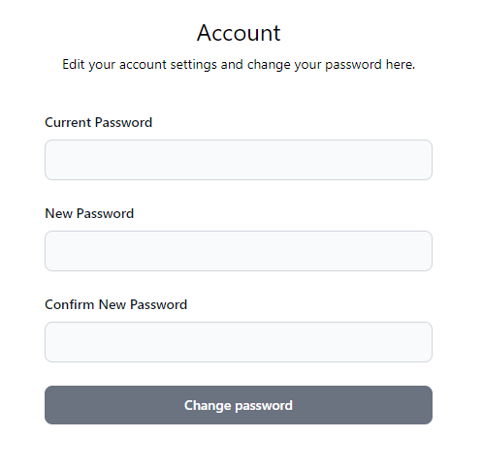

* Function Details: The user can input his/her email to receive the reset password link.

## 2. Public Feature:

### a. Home Page

* “Online Learning” in the browser
* Function description
* Role: Guest
* Purpose: Want to access to the Learning Online Web
* Screen layout:

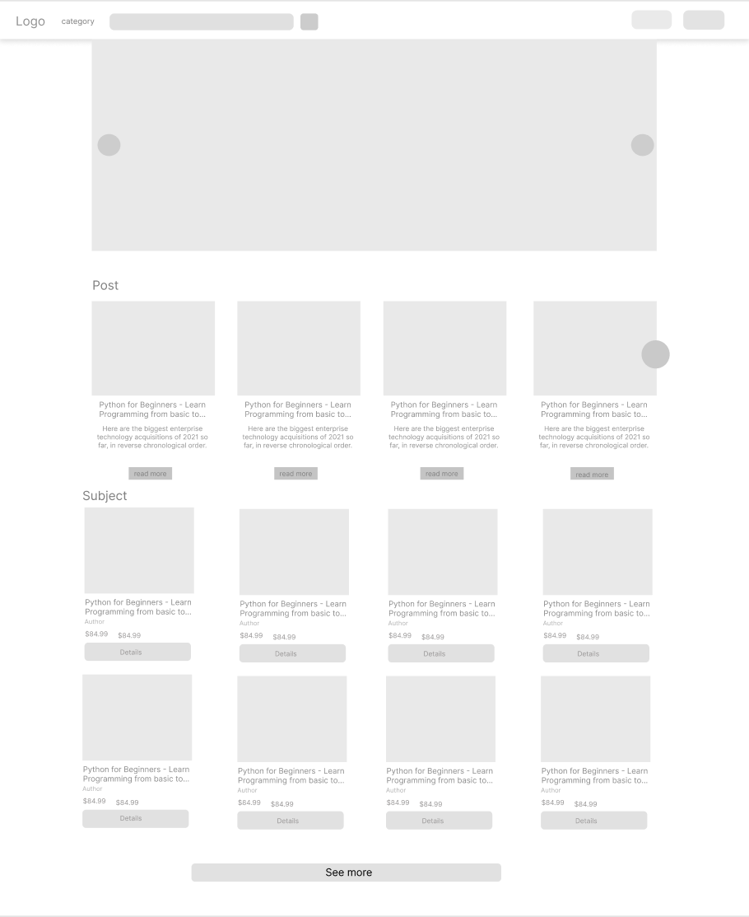

* Function detail:  
  Show sliders, hot posts, featured subjects + the slider with the latest posts, static contacts/links

- Shown slider information includes its image and title; the user is redirected to the slider's backlink on his/her clicking

- Shown post information includes its thumbnail, title, post date; the user is redirected to the post's details on his/her clicking

- Shown subject information includes its thumbnail, title, tag line; the user is redirected to the subject's details on his/her clicking

### b. Blogs List:

* Function trigger: This use case starts when the click List Blogs in the home page
* Function description:
* Role: Guest And User
* Purpose: want to view Blogs
* Screen layout  
  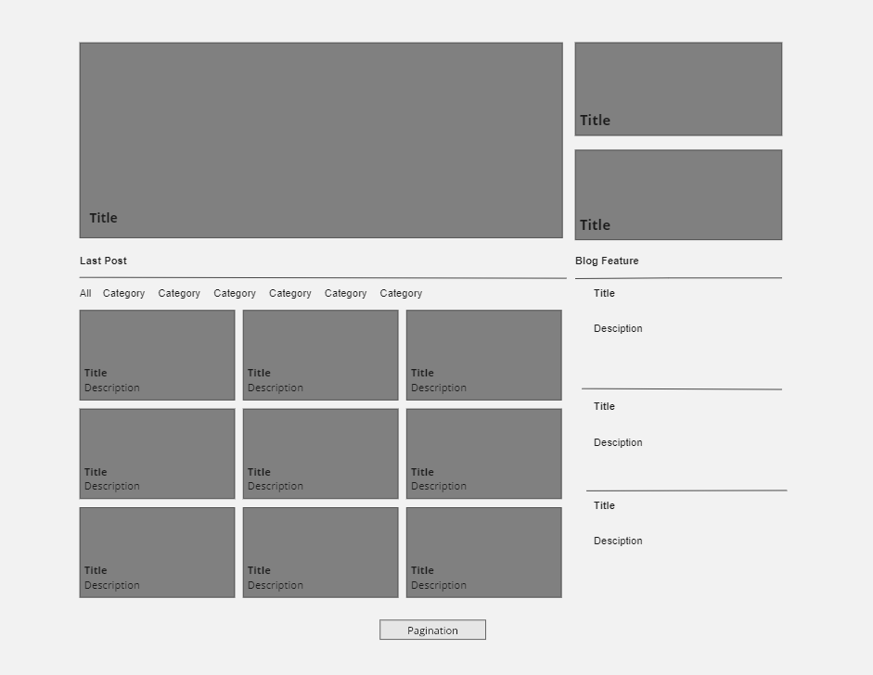

* Function detail:
* Show the posts pagination (sorted by updated date)
* The siders with the post search box, posts categories, latest posts, static contacts/links; Shown post information includes its thumbnail, title, category, brief-info; the user is redirected to the post's details on his/her clicking

### c. Blog Details:

* Function trigger: This use case starts when the click Blog in the List Blog
* Function description:
* Role: Guest And User
* Purpose: want to view Blog detail
* Screen layout

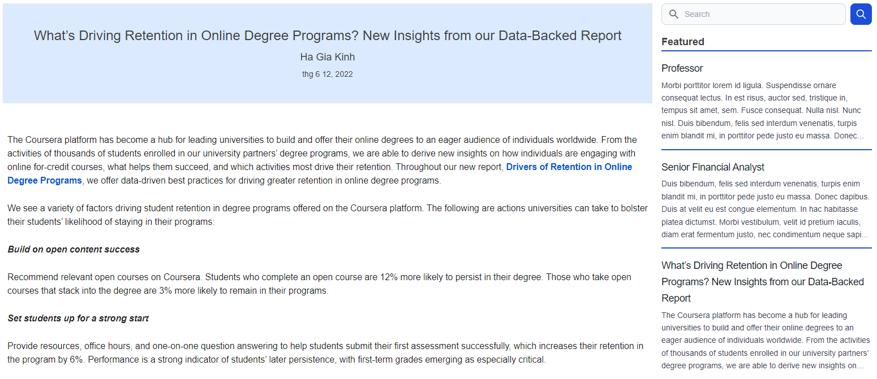

* Function detail:
* Show post details (including title, author, updated date, category, and post details)
* The sider with the post search box, posts categories, latest posts, static contacts/links

### d. Courses List:

* Function trigger: This use case starts when the click List Course in the home page
* Function description:
* Role: Guest And User
* Purpose: want to view Course List
* Screen layout

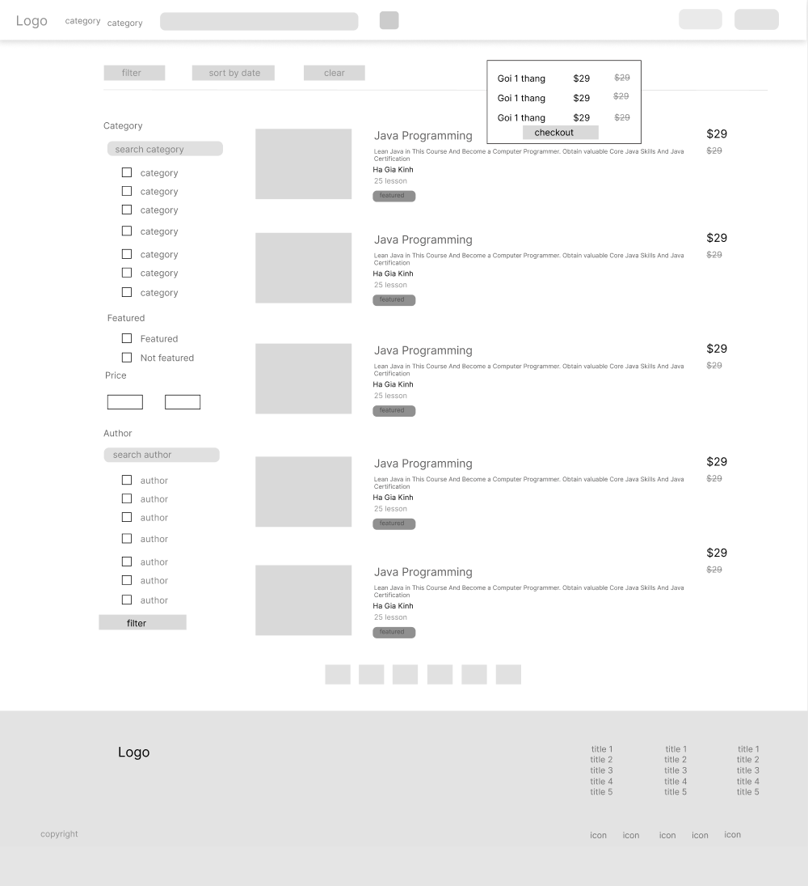

* Function detail:
* Show the subjects paginated (sorted by updated date, paginated)
* The sider with the subject search box, subject categories, featured subjects, and static contacts/links;
* Shown subject information includes its thumbnail, title, tag line, lowest price package option (list price, sale price);
* The user is redirected to the subject's details on his/her clicking on the subject
* The user can choose to register to the subject by clicking the Register button

### e. Courses Details:

* Function trigger: This use case starts when the click Course in the List Course
* Function description:
* Role: Guest And User
* Purpose: want to view Course detail
* Screen layout:

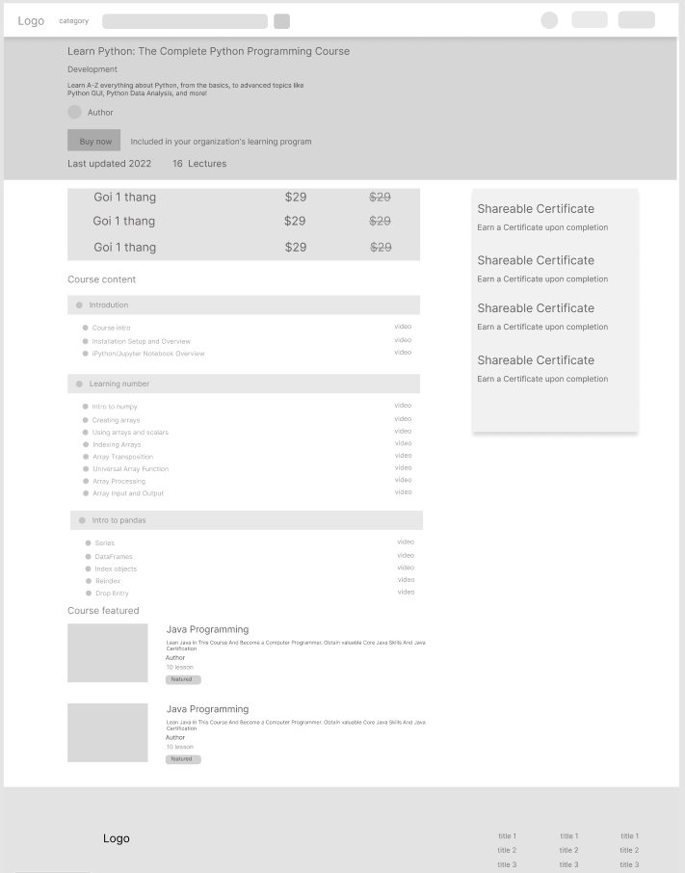

* Function detail:
* Show subject details (including title, tag line, brief info, lowest price package option (original price, sale price), product description, and a Register button)
* The sider with the subject search box, subject categories, featured subjects, static contacts/links

### f. Course Register:

* Function trigger: When the user clicks "Register now"
* Function description: The user wants to register and pay for that course.
* Screen layout:

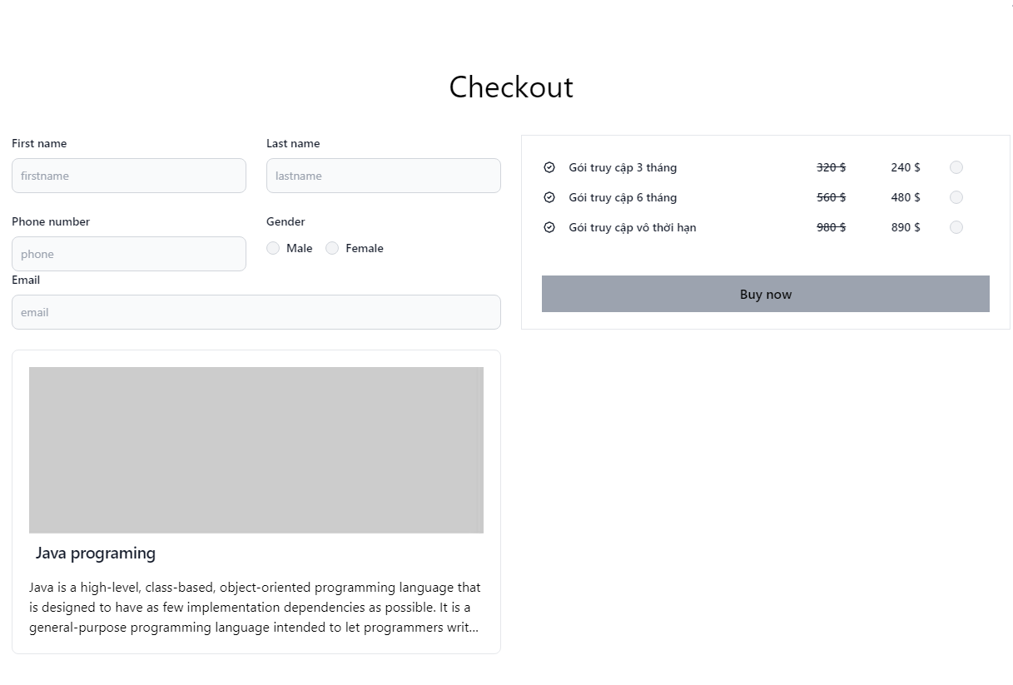

* Function: The user needs to choose appropriate subject price package & input his/her information (full name, email, mobile, gender); A logged in user doesn't have to input those contact information

## 3. Administrator Feature:

### b. Users List:

* Function trigger: This use case starts when the Admin click User List in the Dashboard
* Function description:
* Role: Administrator
* Purpose: Want to view all User
* Screen layout:

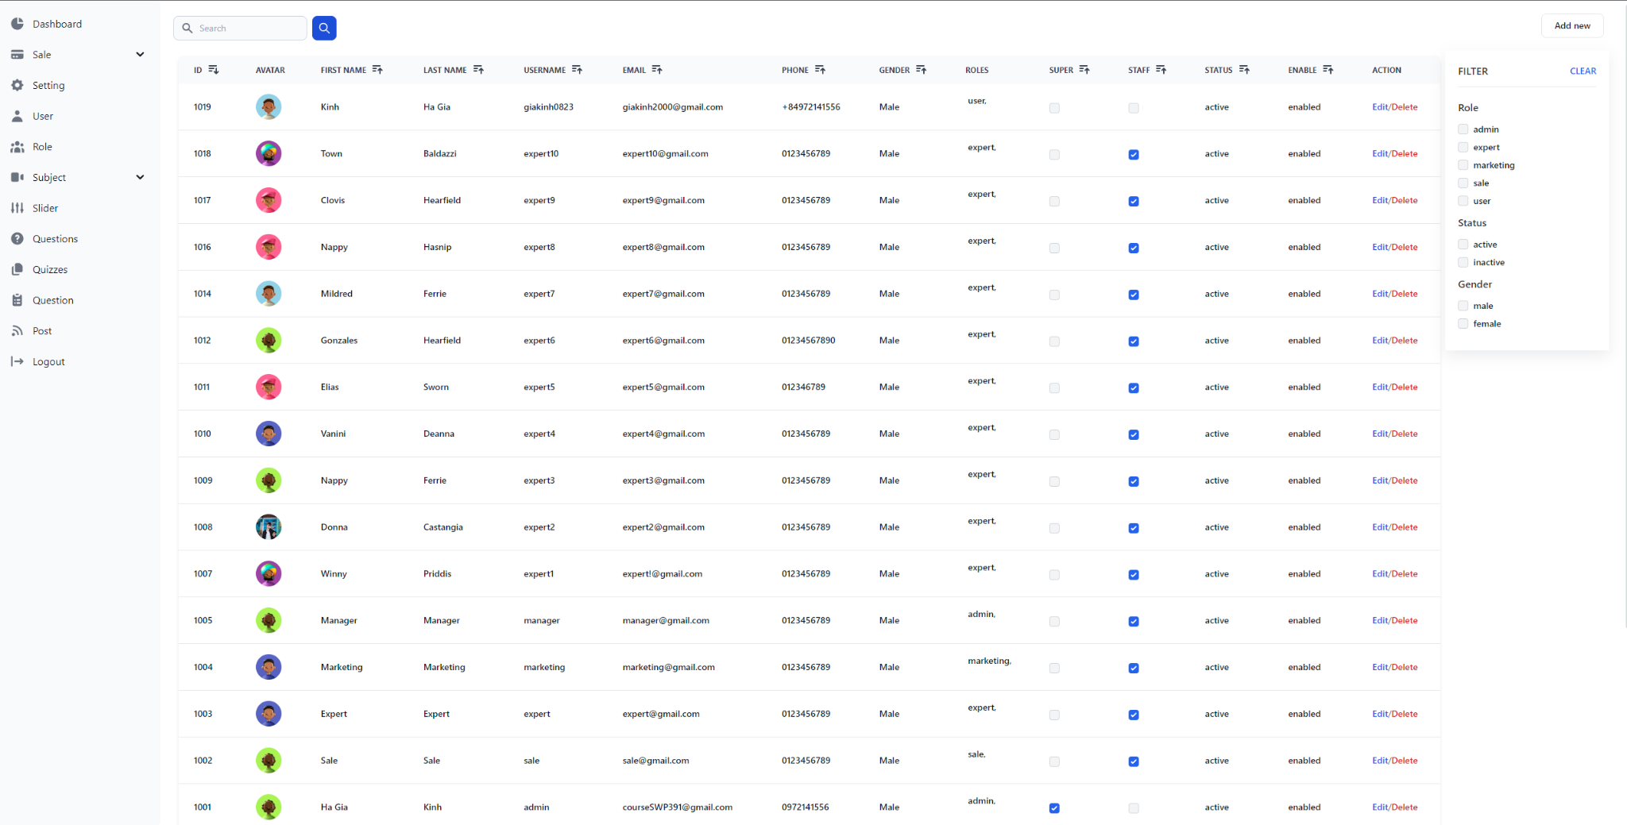

* Function detail:
* System display all User paginated
* Show User information includes ID, Name, Email, and Phone
* If the there is not User in the list, the web will display “User not Found”
* If there is an exception error. The page will redirect to the error display page

### b. Users Details:

* Function trigger: This use case starts when the Manager click User “Detail” of an User in the User list
* Function description:
* Role: Administrator
* Purpose: Want to view User detail
* Screen layout:

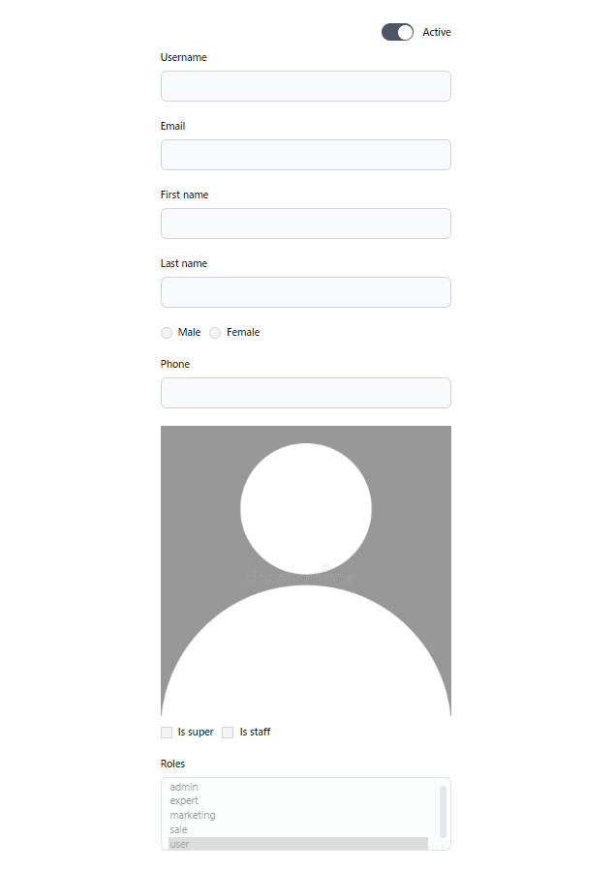

* Function detail:
* In the User List page, the admin clicks on the “Detail” button of any user in order to move to the detail page
* In the User Details page, the user can see information of the User they chose.
* If the user wants to edit User’s information, they can click on the “Edit Profile”
* If the user wants to go back to the User list, they can click on the “Back to List”
* If there is an exception error. The page will redirect to the error display page.

### c. Settings List:

* **Function trigger:** This use case starts when a user click the “Settings List” at the Menu
* **Function description:** Admin wants to see a list of settings and edit them.
* **Screen layout**

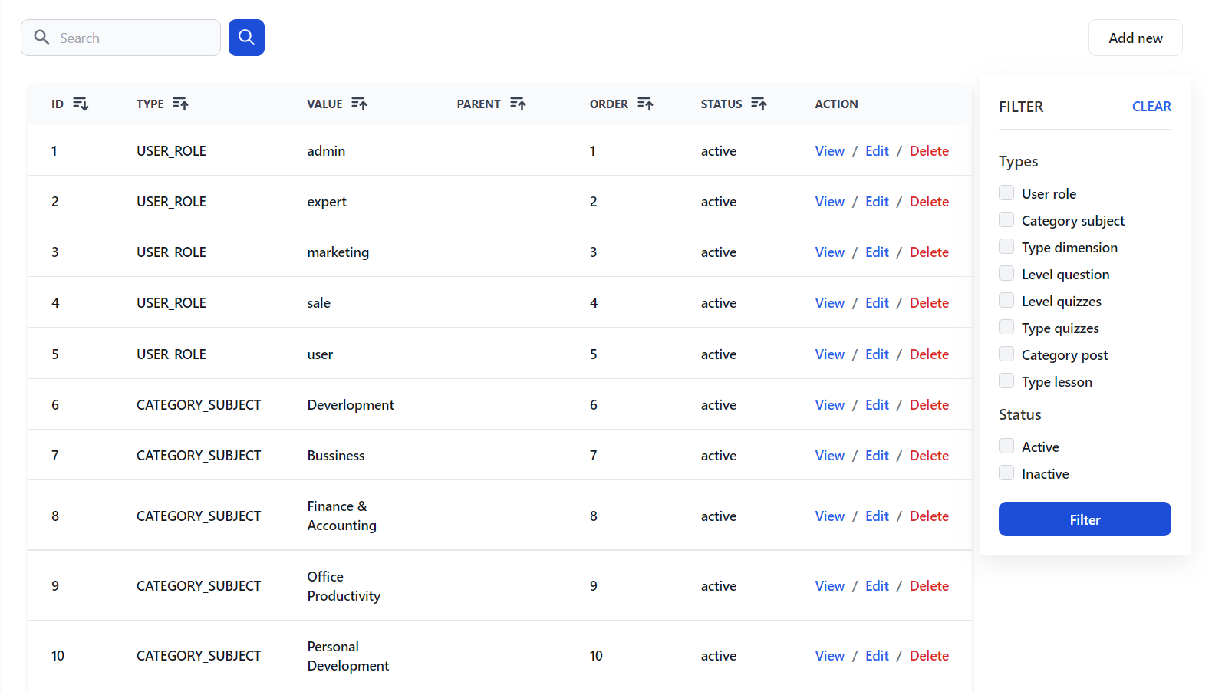

* + Edit:

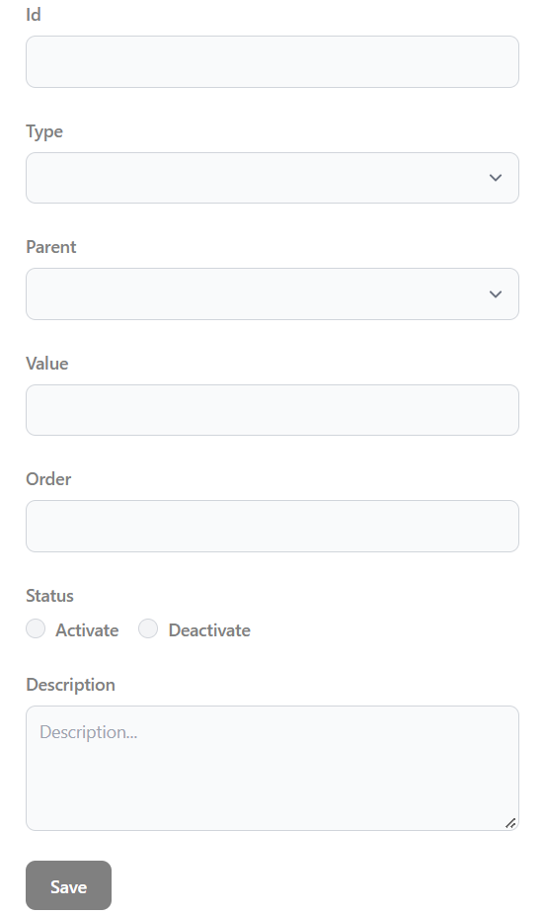

* + Create:

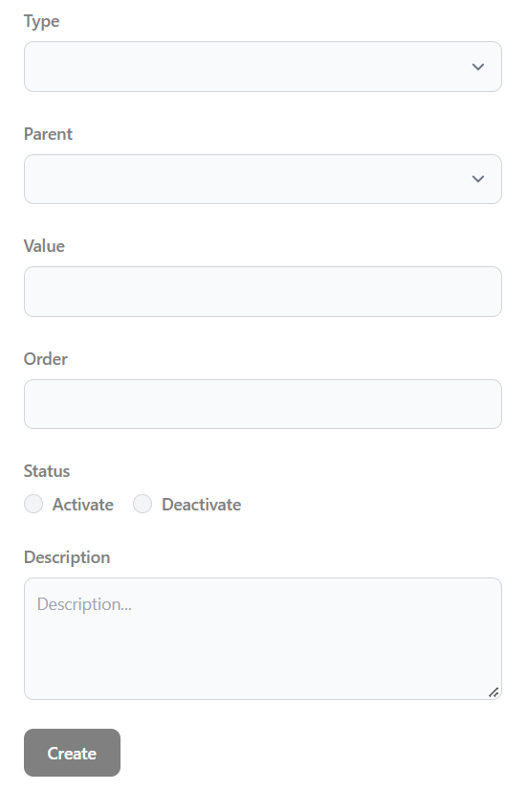

* **Function detail:** Show the paginated list of settings (include settings’ id, type, value, order, status):
* The admin can filter the setting by type, status
* Allow the admin to search settings by value
* The list is sortable by id, type, value, order, status
* From each setting, the admin can choose to view activate/deactivate, or edit it
* The page also has the button/link that allows the admin to add a new setting.

### d. Setting Details:

* **Add new roles:**
* Function trigger: Administrator want to add new role via Settings List
* Function description: Add a administrator, I want to add new role
* Function details: Administrator click button “Add” in Settings List
* **Deactivate roles:**
* Function trigger: Administrator want to deactivate role via Settings List
* Function description: As an administrator, I want to deactivate new role
* Function details: Administrator view Settings List in director page and click button “Deactivate.”
* **Screen layout**
  + View:

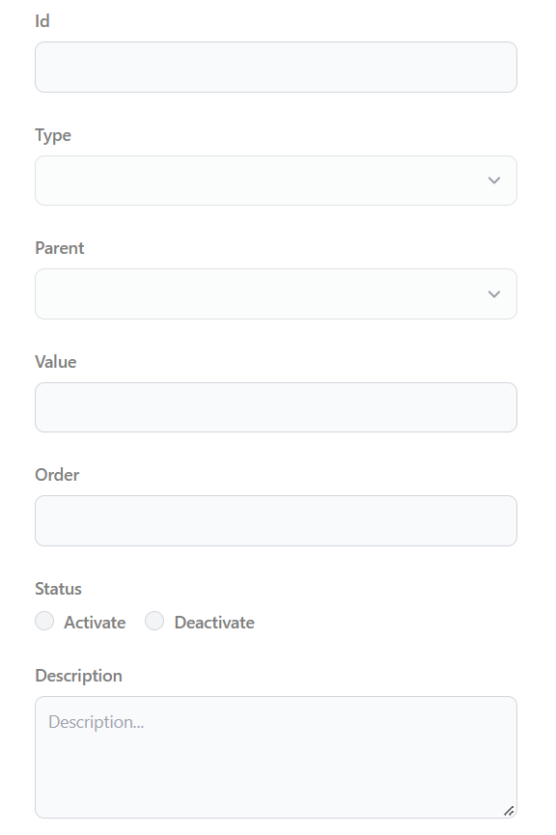

* **Change roles:**
* Function trigger: Administrator want to add new role via Settings List
* Function description: As a administrator, I want to add new role
* Function details: administrator view Settings List in director page and click button “Edit” then forward to Settings Details.
* Administrator can change details of roles

## 4. Marketing Feature:

### a. Dashboard:

* **Function trigger:** When a user logs in as marketing, the page is automatically redirected here
* **Function description:** Show statistics of new subjects, new registrations, revenues, customers, and the trend of order counts
* **Screen layout:**

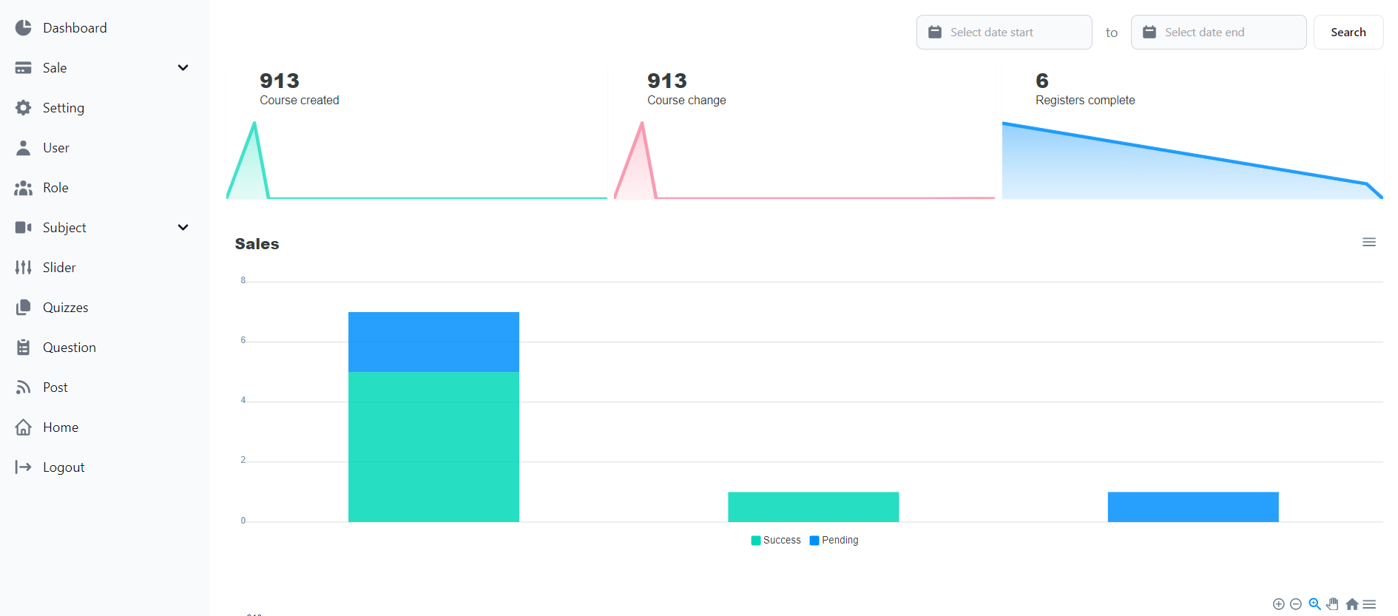

* **Function details:**
* Show statistics:
* New subjects( user can filter by new & all)
* New registrations( user can filter by success, cancelled & submitted)
* Revenues( user can filter by total & subject categories)
* Customers( user can filter by newly registered & newly bought)
* The trend of order counts( user can filter by success & all) by day for the last 7 days

### b. Post List:

* **Function trigger:** This function is activated when the user clicks on PostList in navbar
* **Function description:** Show detailed post information
* **Screen layout:**

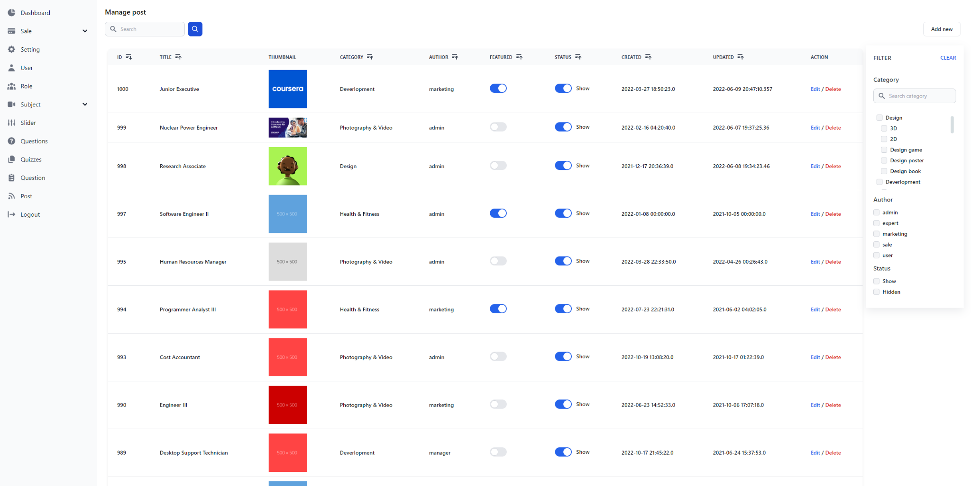

* **Function details:**
* Show the paginated list of posts (include posts' id, thumbnail, title, category, author, featured, and status information):
* - The user can filter the post by category, author, status; also the user can search the post by title
* - The list can be sortable by title, category, author, featured, or status
* - The page also have the button/link that allows the user to add new or choose to view/update/show/hide an existing post

### c. Post Details:

* **Function trigger:** This function is activated when the user clicks on PostList in navbar
* **Function description:** Show detailed post information
* **Screen layout:**
  + Edit:

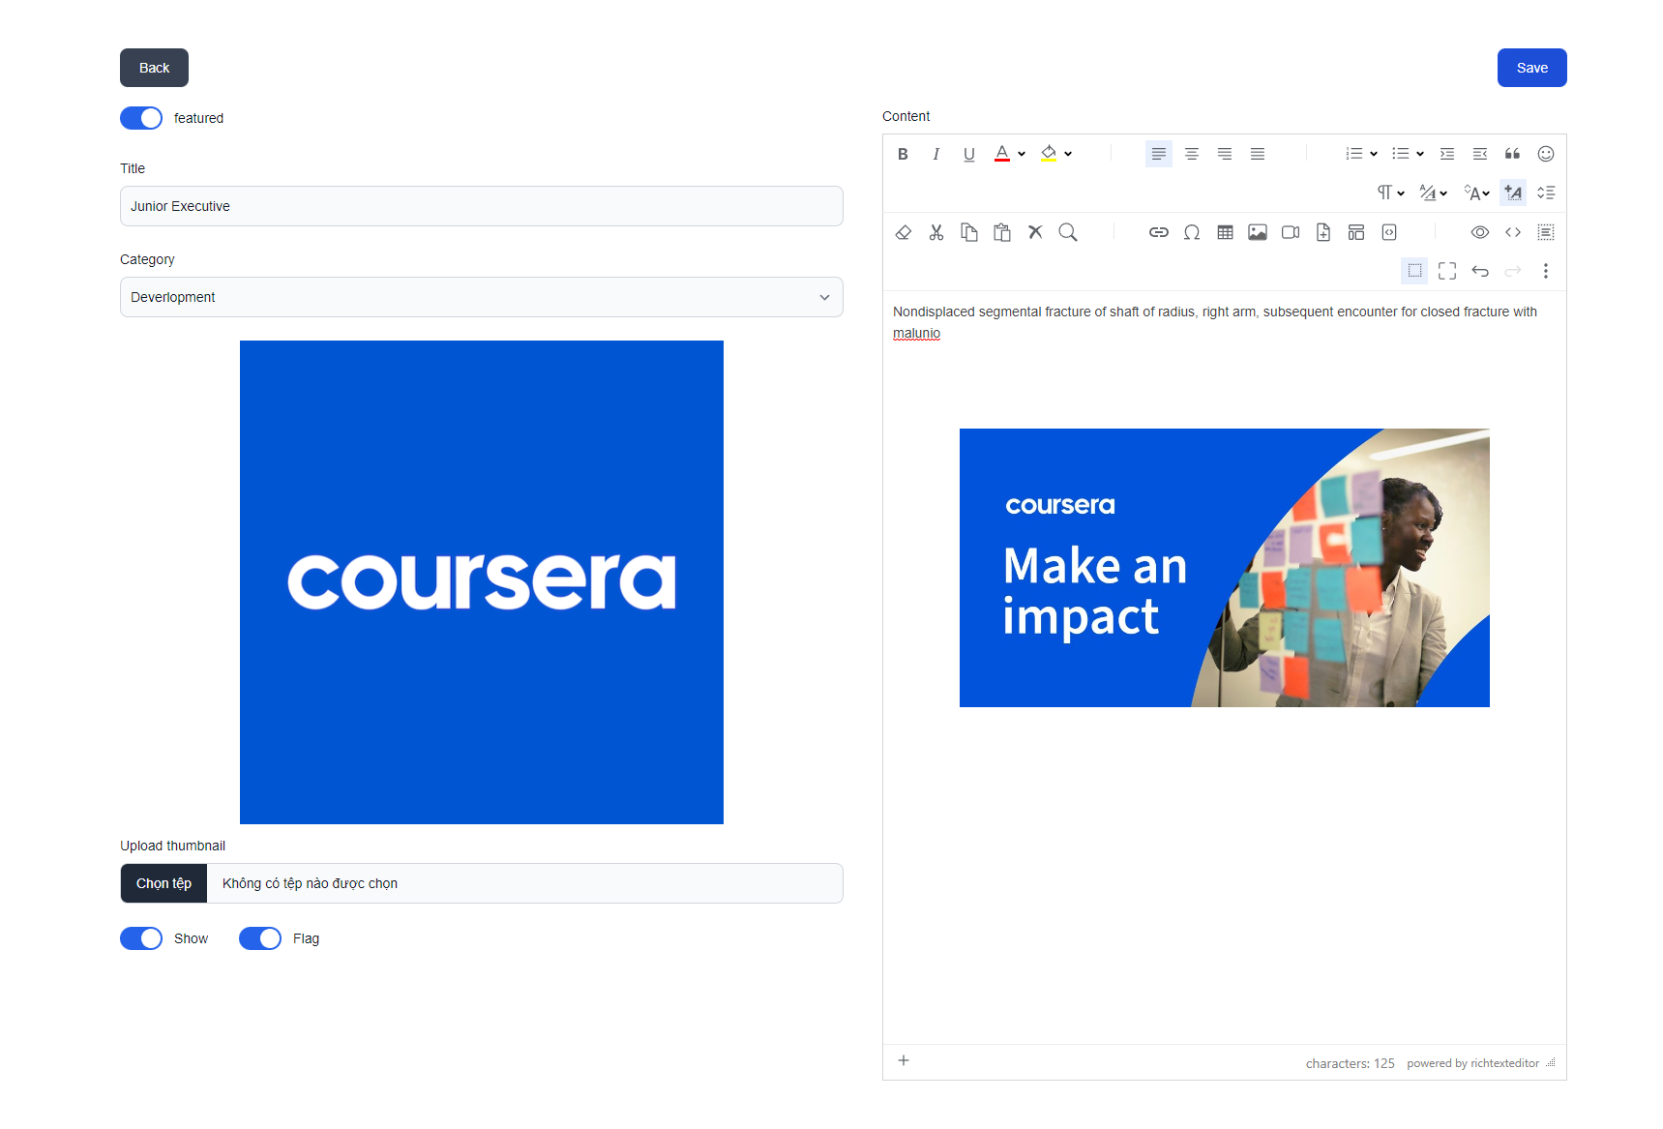

* + Create:

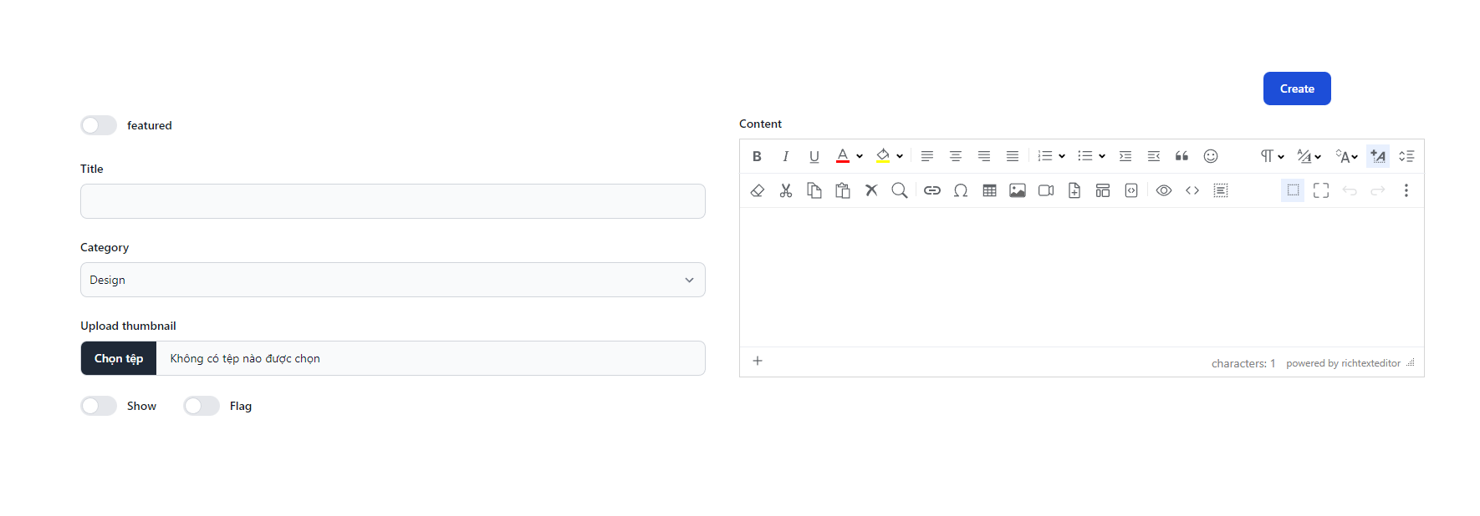

* **Function details:**
* Show post information (thumbnail, category, title, brief information, description, flag to turn the featurning on/off, status)
* The user can input, view or edit post

### d. Slider List:

* **Function trigger:** This function is activated when the user clicks on button Slider
* **Function description:** Show the paginated list of sliders
* **Screen layout:**

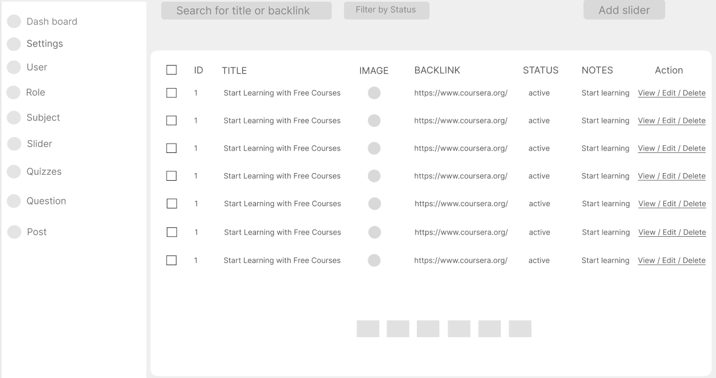

* + View:

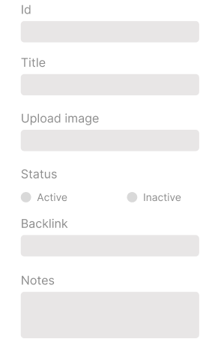

* + Create:

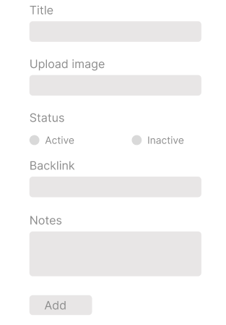

* + Edit

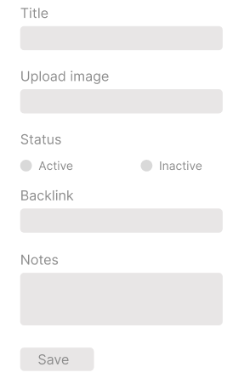

* **Function details:**
* Show the paginated list of sliders (including sliders' id, title, image, backlink, status)
* The user can filter the sliders by the status and search by title or backlink
* For each slider, the user can choose to hide, show, edit it

### e. Slider Details:

* **Function trigger: T**his function is triggered when the user clicks to Slider in the List Slider
* **Function description:** Show slider information
* **Screen layout:**

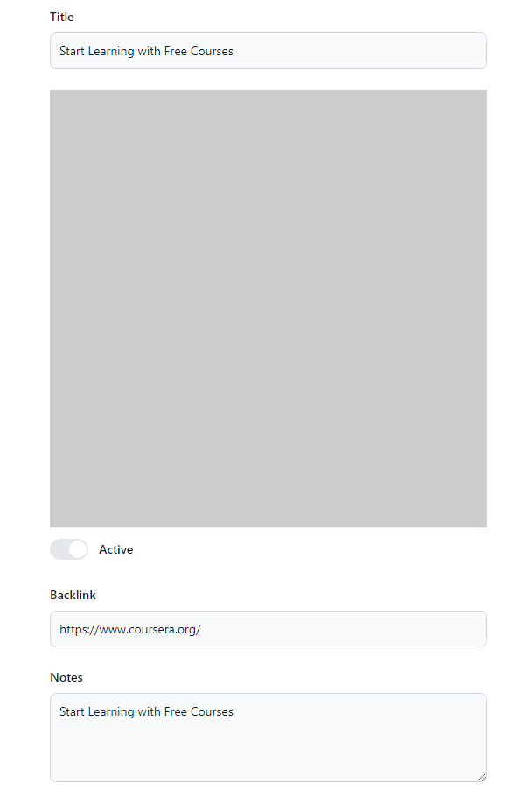

* **Function details:** Show detailed slider information (image, title, backlink, status, notes)

## 5. Customer/Learning Feature:

### a. My Registrations:

* **Function trigger:** This function is activated when the user registers for the course.
* **Function description:** Show the list of user's registration
* **Screen layout:**

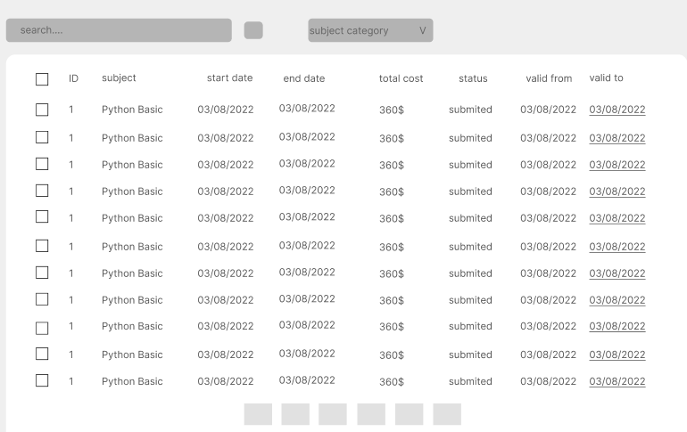

* **Function details:**

If the registration is still in the submitted status, the users can choose to cancel it or coming back to the Course Register pop-up to edit it

### b. My Courses:

* **Function trigger:** When the user clicks on "Courses", the course information will appear
* **Function description:** display information about the courses that the customer is allowed to access
* **Screen layout:**

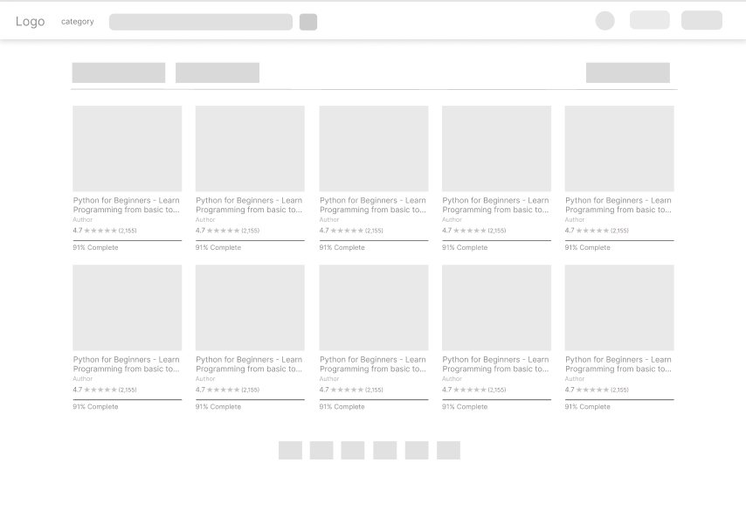

* **Function details:** users can see the courses they have signed

### c. Lesson View:

* **Function trigger:** Function works when user clicks on Course
* **Function description:** Allow customer to access the course lessons for his/her studying
* **Screen layout:**

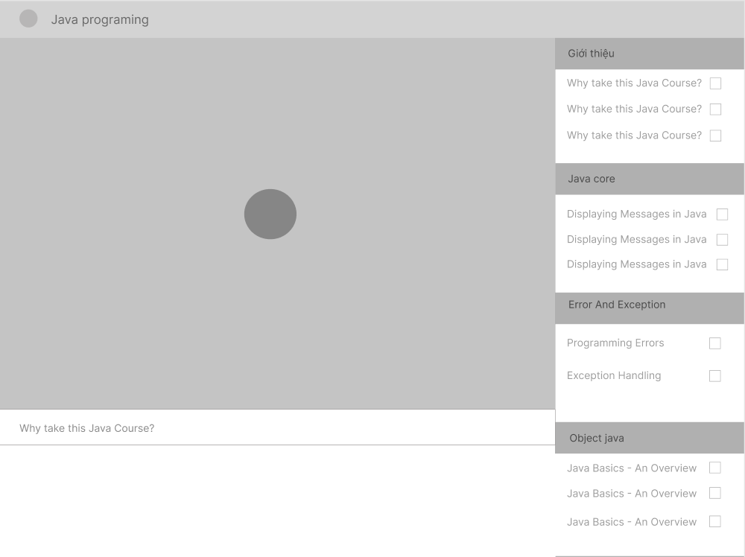

* **Function details:** User can view course duration and learning progress

### d. Quiz Lesson:

* **Function trigger:** This function is triggered when the user clicks: button
* **Function description:** This allows the user to take the topic quiz or view the quiz results
* **Screen layout:**

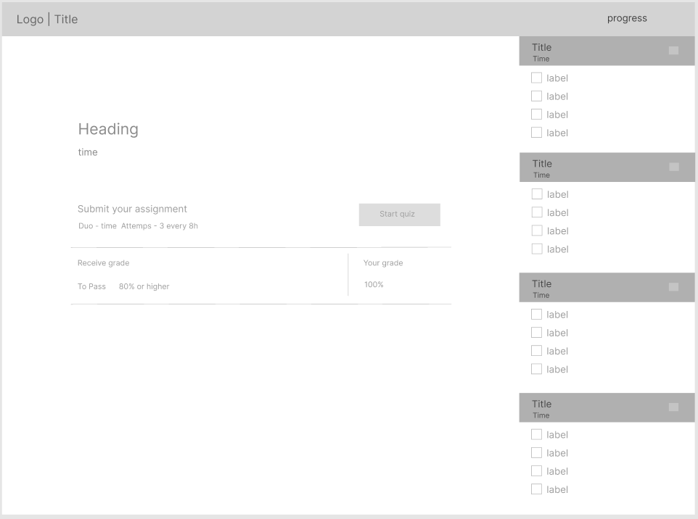

* **Function details:**
* Show quiz details (includes questions and answers)
* User can view the results quiz

### e. Quiz Handle:

* **Function trigger:** This function is triggered when the user clicks to Quiz Handle
* **Function description:** This screen allows the user to browse and answer the quiz questions.
* **Screen layout:**

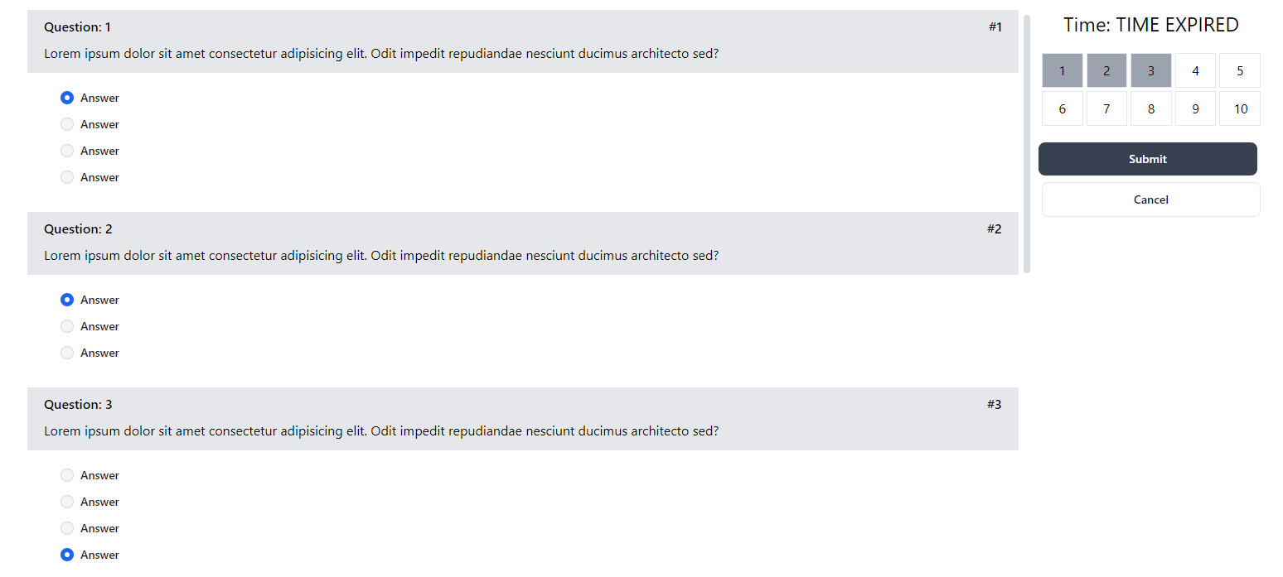

* **Function details:**
* User selects and answers questions
* The timer is counting down
* During quiz-taking progress, if the user chooses to refresh the page, there is no impact.
* Review Progress button: with 4 options UnAnswered, Marked, Answered, and All Questions

### f. Quiz Review:

* **Function trigger:** The function works when the user clicks the "Explanation" button.
* **Function description:** This screen allows the user to review the details of the quiz that s/he has just taken
* **Screen layout:**

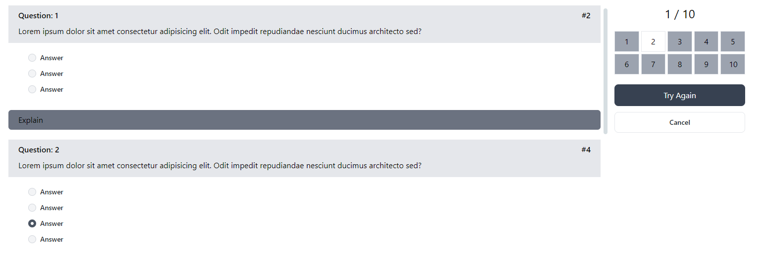

* **Function details:**
* User can see right or wrong answer through "Review Result" button
* User can see the explanation corresponding to each question
* User can move to next question

## 6. Course Content Feature:

### a. Subject List:

* Function trigger: This use case starts when the Admin click Subject List in the Dashboard
* Function description:
* Role: Administrator
* Purpose: Want to view all Subjects
* Screen layout:

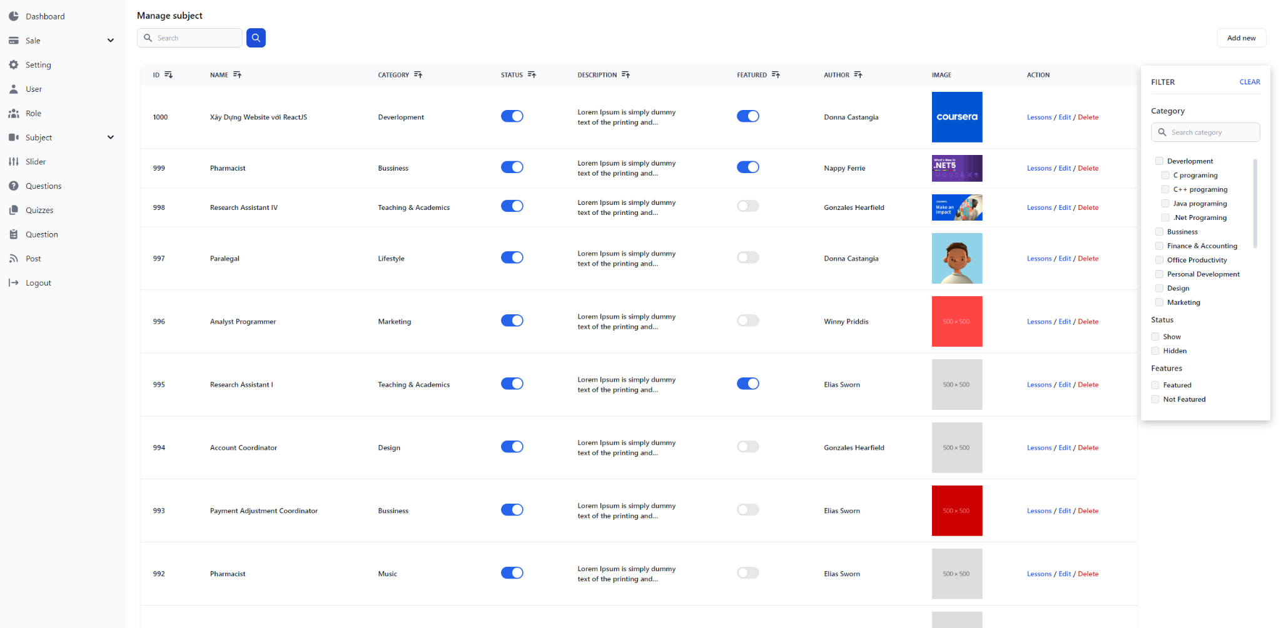

* Function detail:
* System display all Subjects paginated
* Show User information includes id, name, category, number of lessons, owner, and status
* Filter the list by course category & status
* If the there is not Subject in the list, the web will display “Subject not Found”
* If there is an exception error. The page will redirect to the error display page

### b. New Subject:

* Function trigger: This use case starts when the Admin click New Subject List in the Subject List
* Function description:
* Role: Administrator
* Purpose: Want to new a Subject
* Screen layout:

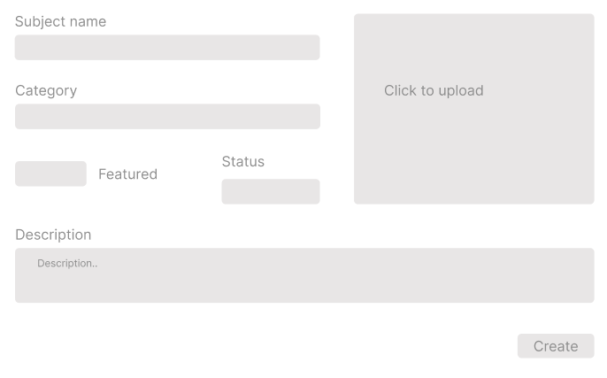

* Function detail:
* Input new course information: name, thumbnail image, category, featured flag, owner, status, and description

### c. Subject Details:

* Function trigger: This use case starts when the Admin click view subject in the Subject List
* Function description:
* Role: Administrator and expert
* Purpose: Want to view Subject Detail and Published or Unpublished add/edit price package
* Screen layout:
  + View:

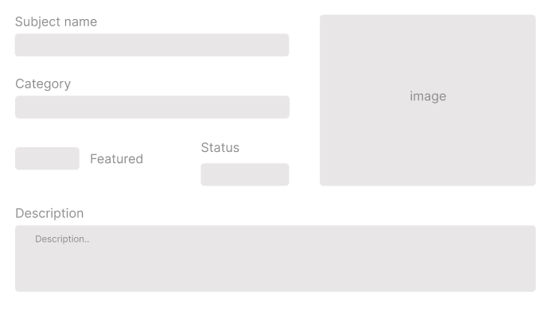

* + Edit:

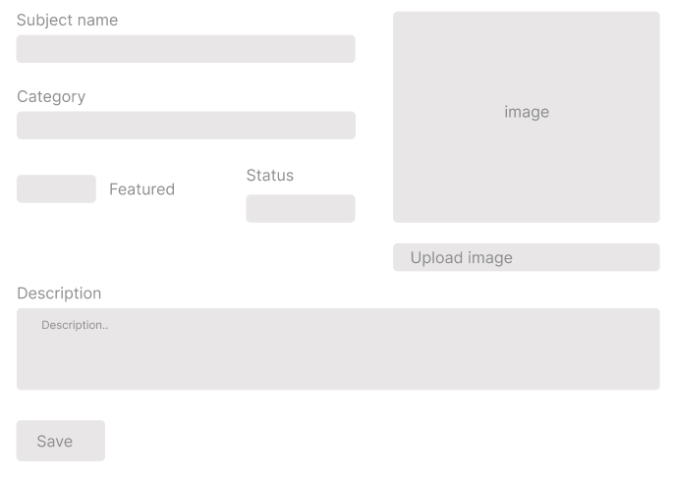

* Function detail:
* Prepare the subject information, including the course general information, the dimension, and price package
* Only admin can change the status to Published or Unpublished + add/edit the price packages

### e. Price Package:

* Function trigger: This use case starts when the Admin click button “Price package” in the Subject detail
* Function description:
* Role: Administrator and expert
* Purpose: Want to view price package and add/edit price package
* Screen layout:

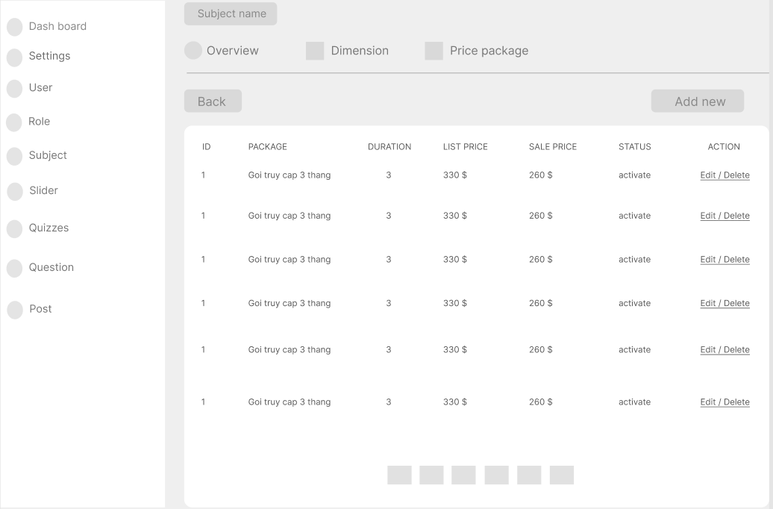

* + Create:

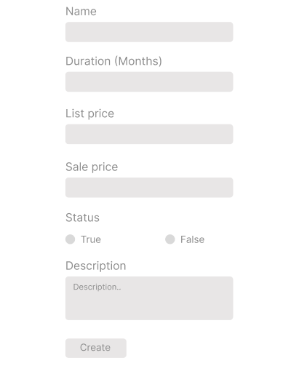

* + Edit:

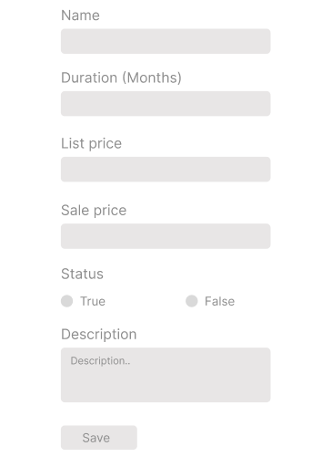

* Function detail:
* Experts can only view the information.
* admin to input or edit subject dimension information, including the following detailed information: name, access duration (in months), status (read-only), list price, sale price, description.

### f. Subject Lessons:

* Function trigger: This use case starts when the Admin/expert click “Lesson” at the Subject details
* Function description:
* Role: Administrator and expert
* Purpose: Shows the list of lessons for a selected package and allowed to activate/deactivate or add/edit lessons.
* Screen layout:

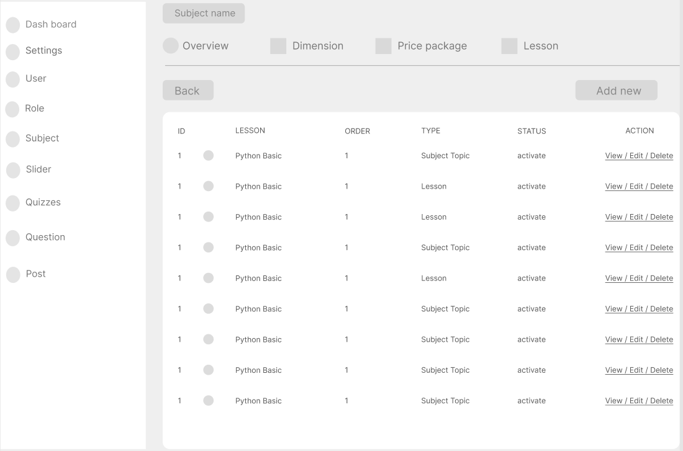

* Function detail:
* This page shows the list of lessons for a selected package
* The admin/expert is allowed to activate/deactivate, or call the Lesson Details for adding new or editing existing lesson

### g. Lesson Details:

* Function trigger: This use case starts when the Admin click view lesson detail in the Subject lesson
* Function description:
* Role: Administrator and expert
* Purpose: Input/edit the lesson information
* Screen layout:

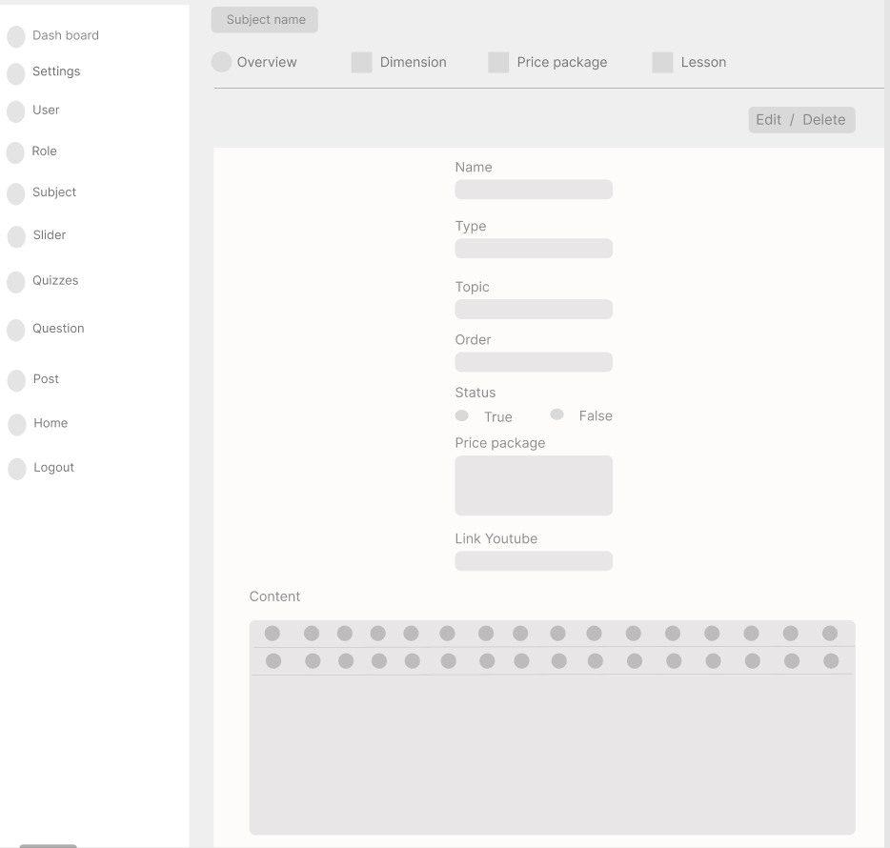

* Function detail:
* Admin/expert to input/edit the lesson information

### h. Subject Dimension

* Function trigger: This use case starts when the Admin click button “Dimension” in the Subject detail
* Function description:
* Role: Administrator and expert
* Purpose: Input or edit subject dimension information
* Screen layout:

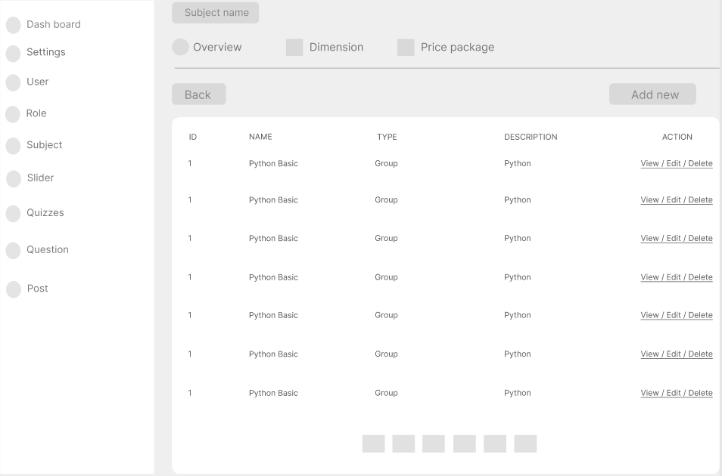

* + View:

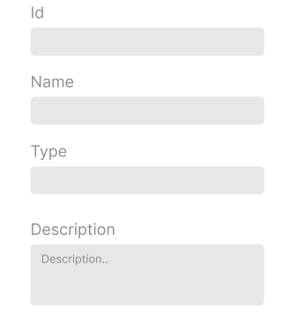

* + Create:

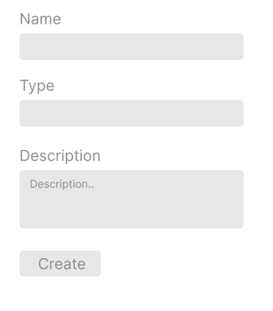

* + Edit

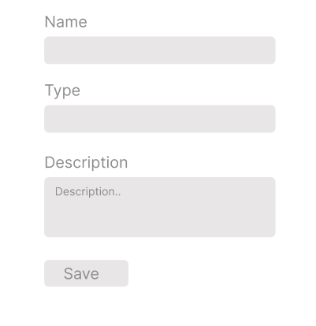

* Function detail:
* Admin/expert to input or edit subject dimension information, including the following detailed information: type, name, description

## 7. Test Content Feature:

### a. Question List:

* Function trigger: admin/expert And User login and access Dashboard then click List questions
* Function description:
* Role: admin/expert And User
* Purpose: Admin/expert filter questions and search by content and allow users to enter questions
* Screen layout:

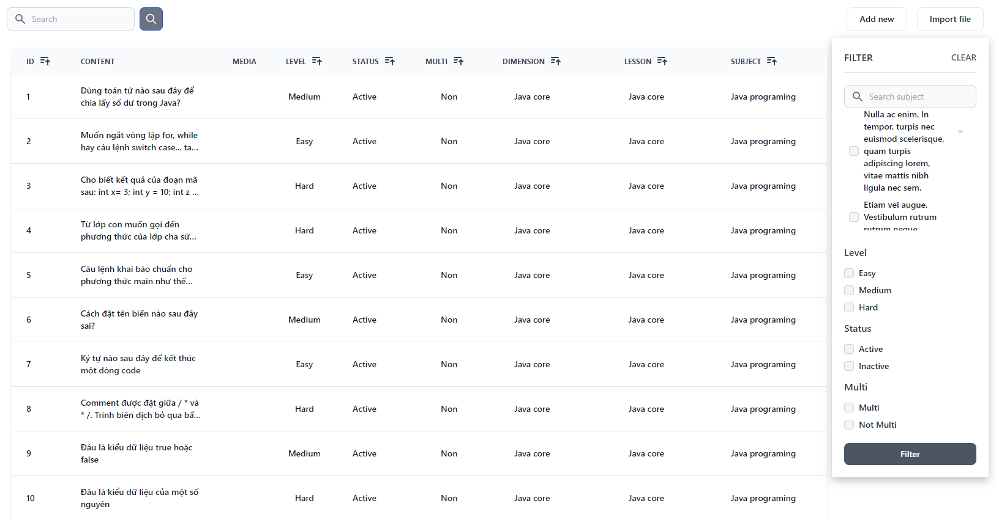

* Function detail:
* The existing questions list for a specific subject/course are shown here (paginatedly).
* On this screen, the admin/expert is allowed to filter the questions by the subject, lesson, dimension(s), level, status + search the questions by the content.
* The page also allows the user to import the question (redirect him/her to the Questions Import pop-up screen.

### b. Question Details:

* Function trigger: admin/expert login and access Dashboard then click List questions and choose Question Details
* Function description:
* Role: admin/expert
* Purpose: input or edit questions information
* Screen layout:

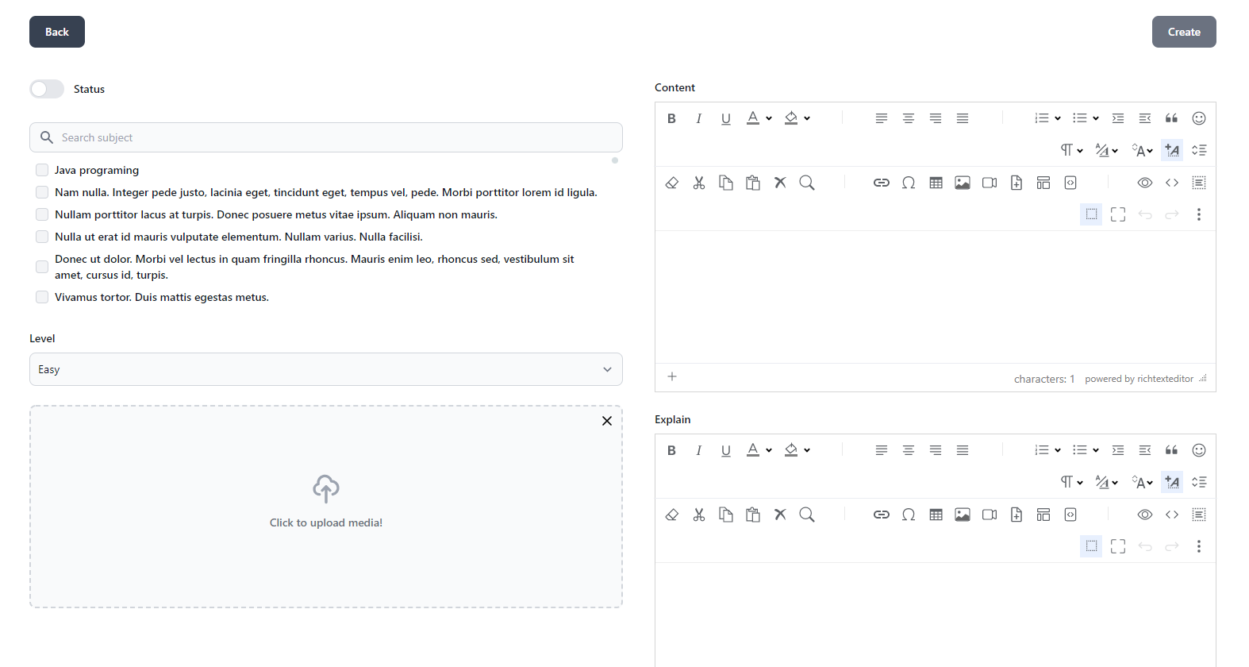

* Function detail:
* This page allows the admin/expert to input or edit questions information, including following information: subject, dimension(s), lesson, status, content, media (image, audio, video – with preview option), answer options (with the key marked + ability to add, edit, delete), and explanation

### c. Question Import:

* Function trigger: Function description:
* Role: User
* Purpose: user to choose import file and then import the questions
* Screen layout  
  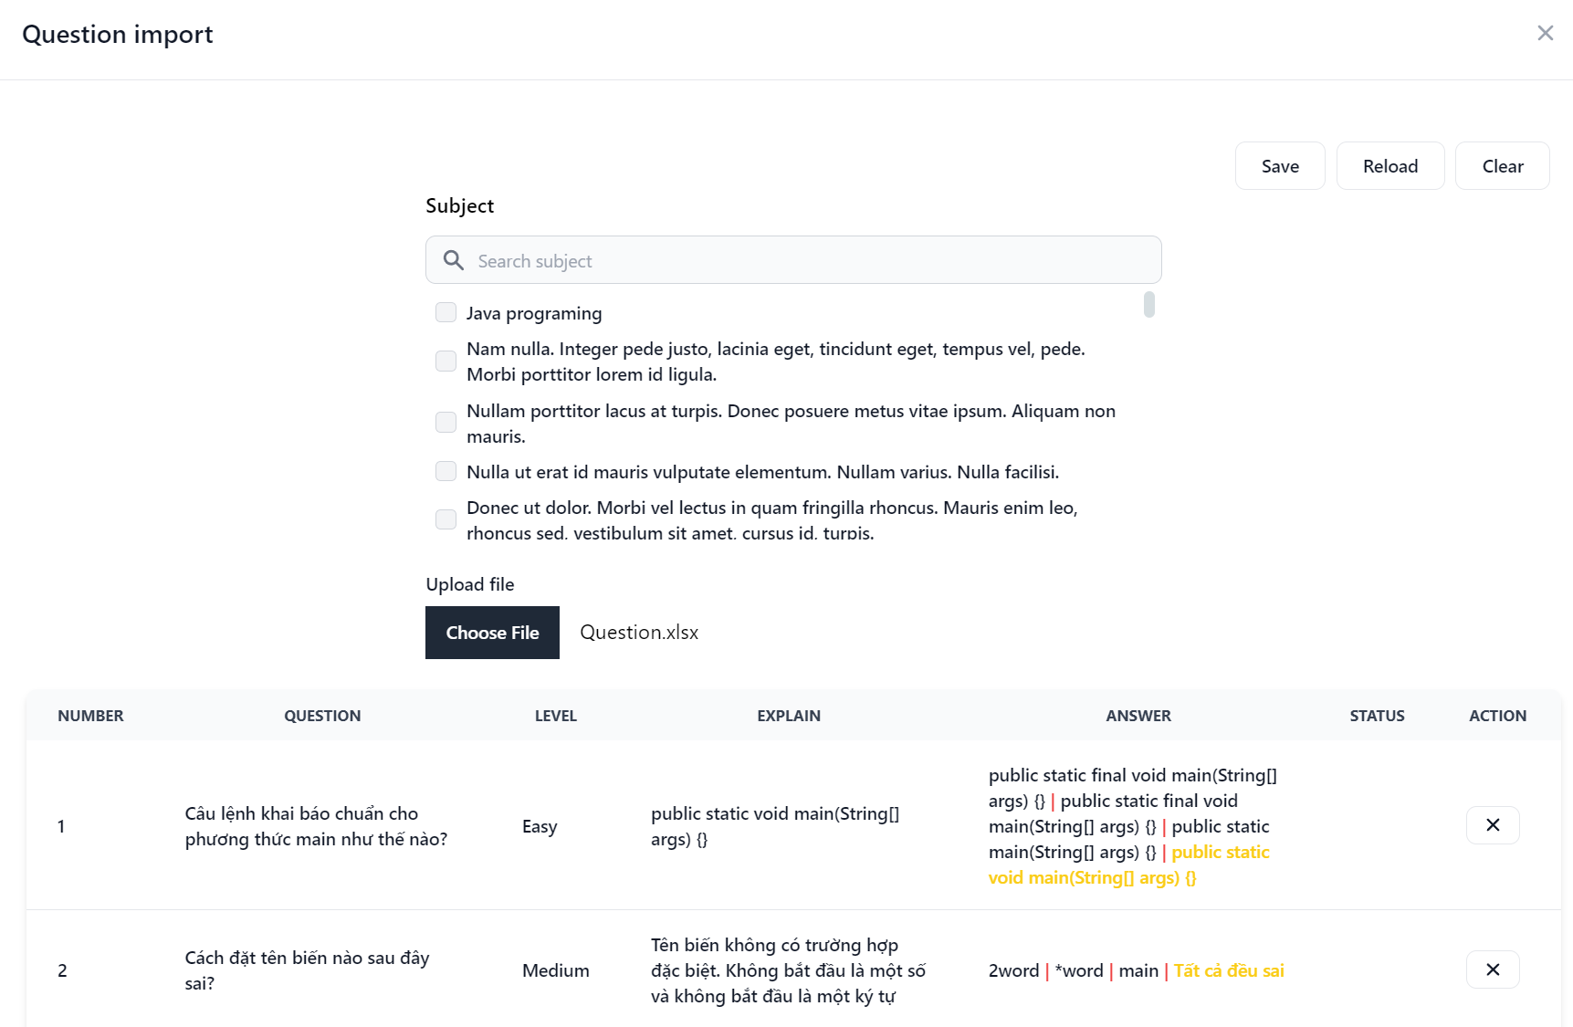

* Function detail:
* This is a pop-up screen which allows the user to choose the import file and then import the questions in the file into the questions bank.
* The screen also provides the option for the user to download the sample import template.

### d. Quizzes List:

* Function trigger: This use case starts when user login and click My course->View lesson->Quiz lesson
* Function description:
* Role: User
* Purpose: user can filter the list by subject, quiz types + search quizzes by the name
* Screen layout

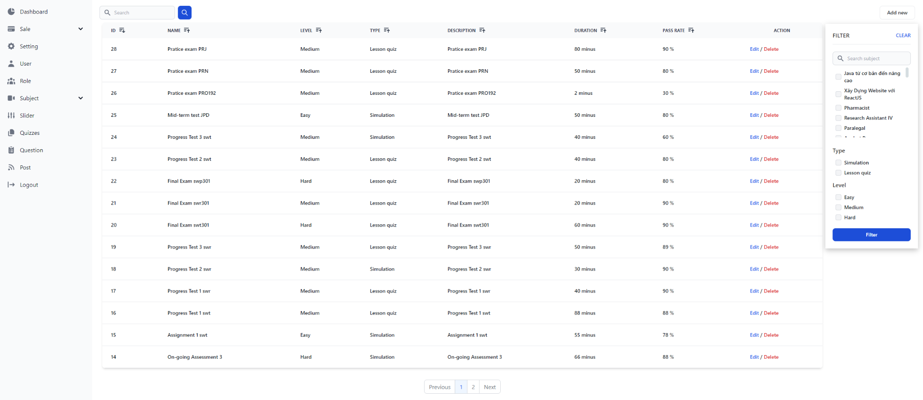

* Function detail:The existing quizzes are shown in this page pagination:
* The user can filter the list by subject, quiz types + search quizzes by the name
* Each quiz includes following information: id, name, subject, level, # question, duration, pass rate, and the quiz type
* From this page, the user has the option to call to the Quiz Details page for adding new or editing existing quizzes + delete the quiz.
* Please note that the quiz can be edited only when there is not any test taken yet

### e. Quiz Details:

* Function trigger:This use case starts when clicking on the Question Details page and selecting Quiz Details
* Function description:
* Role: User
* Purpose: input or edit quiz information
* Screen layout:

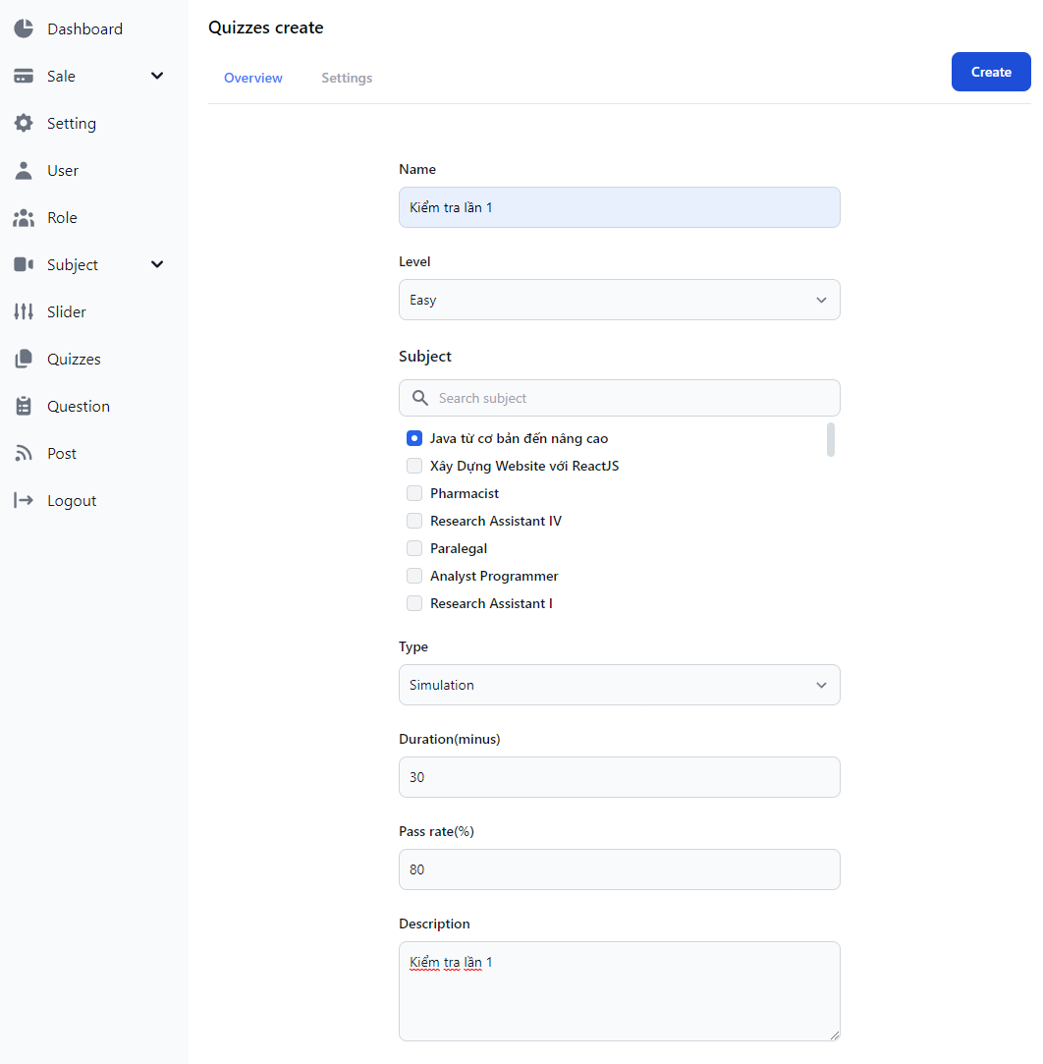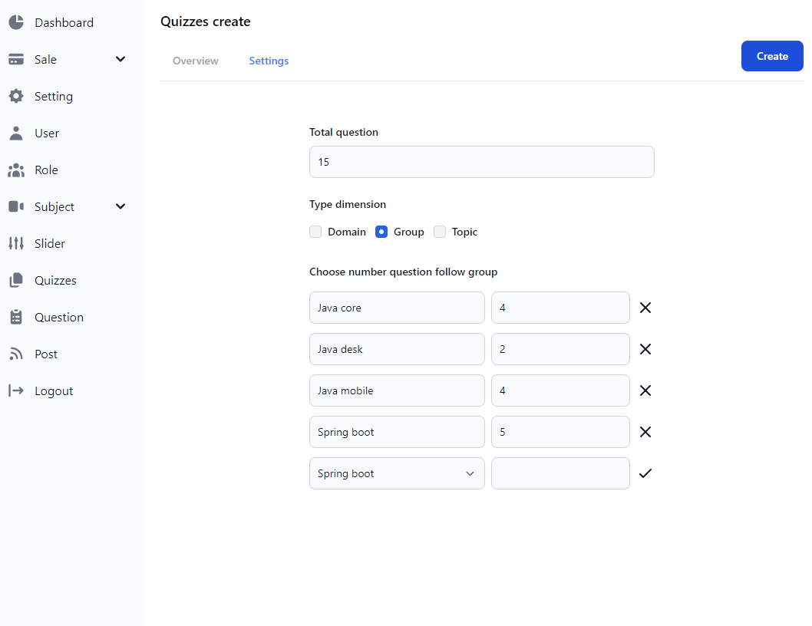

* Function detail:
* This page allows the user to input or edit quiz information. The screen layout is as below

## 8. Sale Feature:

### a. Registrations List:

* Function trigger: This use case starts when the click list of users' registrations **->** New user registrations
* Function description:
* Role: Guest And User, admin
* Purpose: Show the list of users' registrations
* Screen layout  
  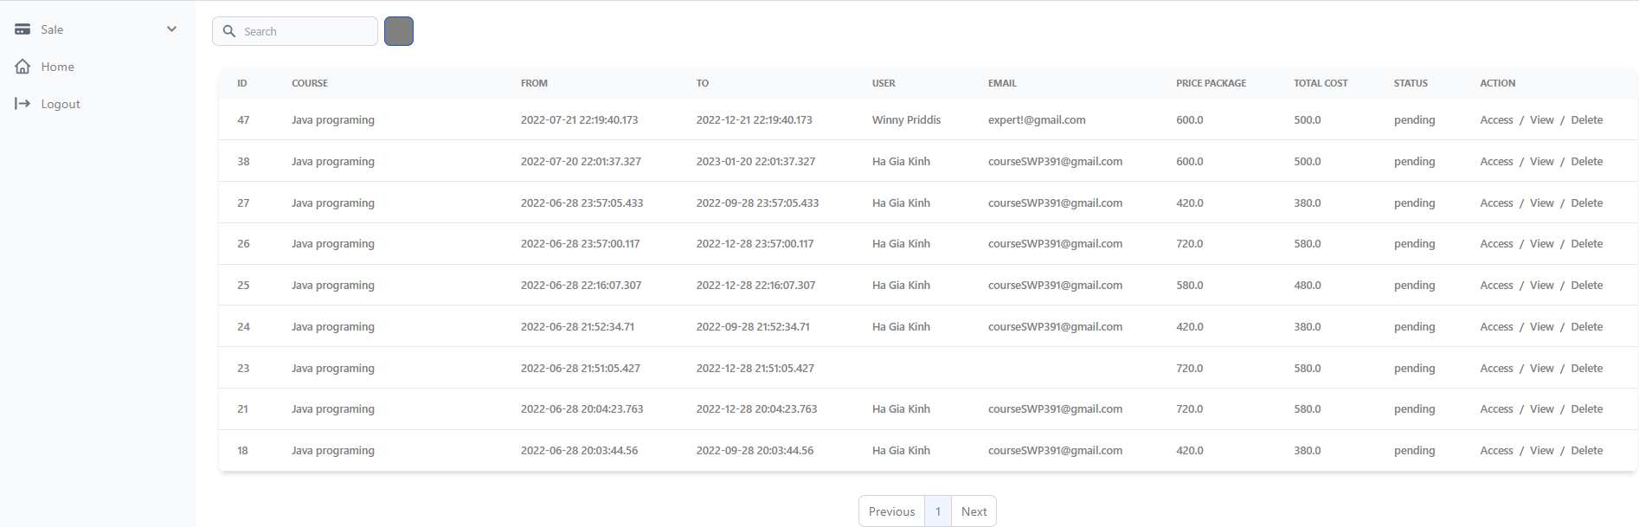

* Function detail:
* Each registration includes below information: id, email, registration time, subject, package, total cost, status, valid from, valid to, last updated by;
* The user can filter the list by subject (searchable), registration time (from, to), status + can search by the email
* The list can be sorted by id, email, registration time, subject, package, total cost, status, valid from, valid to
* From the list, the user can choose to add new or edit an existing registration via the Registration Details screen as below

### b. Registration Details:

* Function trigger: This use case starts when the click list of users' registrations ->users' registrations detail
* Function description:
* Role: Guest And User, admin
* Purpose: 'Show detailed registration information
* Screen layout  
  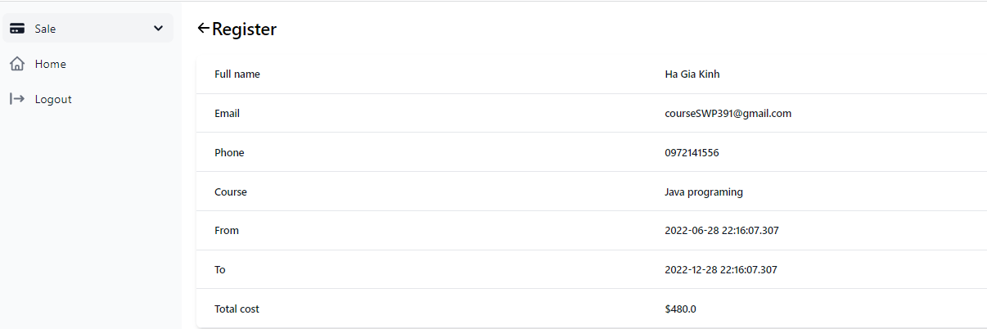

* Function detail:
* Show detailed registration information (subject, package with list price/sale price, full name, gender, email, mobile), registration time, sale, status, valid from, valid to, notes) from that for the user to add new or change the status of a registration with relevant notes (if a registration is created by the user, then s/he can edit other registration information).
* On changing a registration status to Paid, if the user with relevant registered email does not exist, the system would create one and send back to the user the login information (link, email, pass) along with the other notification notes